|  |
| --- |
| A  Project Report  On  “HEART DISEASE PREDICTION USING PYTHON”    Submitted in partial fulfillment of  the requirements for the 4th Semester Sessional Examination of  MASTERS OF COMPUTER APPLICATIONS  By  P.SAI CHANDU (21MCA106)  ELLA BHANU PRASAD (21MCA140)  Registration No:  21PG030089 21PG030053    Under the Supervision of  Dr. Premansu Sekhar Rath  Assistant Professor      SCHOOL OF SCIENCES  DEPARTMENT OF COMPUTER SCIENCE & APPLICATIONS  GANDHI INSTITUTE OF ENGINEERING AND TECHNOLOGY  UNIVERSITY, GUNUPUR-765022  2021-2023 |
| “HEART DISEASE PREDICTION USING PYTHON”    A Project submitted  in partial fulfilment of the requirements  for the Degree of    Masters of Computer Applications  By  P.SAI CHANDU (21MCA106)  ELLA BHANU PRASAD (21MCA140)    (Registration No. 21PG030089, 21PG030053)  Under the Supervision of  Dr.Premansu Sekhar Rath Assistant Professor    DEPARTMENT OF COMPUTER SCIENCE & APPLICATIONS  GIET UNIVERSITY, GUNUPUR-765022, ODISHA  2022 – 2023  ii |

CERTIFICATE

This is to certify that the project work entitled “Heart Disease Prediction Using Python” is done by Name- P.SAI CHANDU (21PG030089), ELLA BHANU PRASAD (21PG030053), in partial fulfilment of the requirements for the 4th Semester Examination of Master of Computer Applications during the academic year 2022-23. This work is submitted to the department as part of the 4th Semester Major Project evaluation.



Project Supervisor Project Coordinator

External Examiner HoD, MCA & BCA

iii

ACKNOWLEDGEMENT

We express our sincere gratitude to Dr. Sanjay Kumar Kuanar, Deputy Dean, of Computational Sciences for giving me an opportunity to accomplish the project. With his active support and guidance, this project report has been successfully completed.

We also thank Prof. Satya Narayan Das, Head of The Department of MCA & BCA for his consistent support, guidance, and help.

We also thank “Dr.A.V.S Pavan Kumar” our Project Coordinator for guidance and help.

We also thank “Dr.Premansu Sekhar Rath”our Project Supervisor for guidance and help.

Signature of the Students

# Contents

Page Number

Abstract

1. Introduction 1
   1. Purpose 1-2
   2. Project Scope 2-3
   3. Project Features 3-20
2. Literature Review 20-22
3. Problem Statement 22-25
4. System Analysis 25
   1. Identification of Need 25-27
   2. Preliminary Investigation 27
   3. Feasibility Study 27-29
   4. Project Planning 29-30
   5. Software requirement specifications (SRS) 30-37
   6. Software Engineering Paradigm applied 37-40
5. System Design &Specifications 41
   1. Data models (like DFD) 41-42
   2. Entity Relationship Model 43
   3. Use-case Diagrams/Activity Diagrams depending upon your project

requirements 44-45

* 1. Class Diagrams 45-46
  2. State Diagrams/Sequence diagrams 46-48

1. Screenshots of the project 48-49
2. Testing 49
   1. Testing techniques and Testing strategies used Testing Plan used 50-54
   2. Test reports for Unit Test Cases and System Test Cases 54-55
3. Conclusion 55-57
4. Future Enhancement 57-58
5. References / Bibliography 58-59

**ABSTRACT**

Heart disease is a leading cause of death worldwide, with an estimated 17.9 million deaths annually. Early detection and accurate diagnosis are crucial for effective treatment and management of heart disease. Machine learning (ML) algorithms have shown promise in improving the accuracy of diagnosis and prediction of heart disease. In this ML project, we aim to develop a model that can accurately predict the presence of heart disease based on patient data. We will use a dataset of patient information that includes demographic data, medical history, and diagnostic test results. The dataset is sourced from the UCI Machine Learning Repository and contains information from 303 patients. We will pre-process the data by performing exploratory data analysis and data cleaning. We will then use a range of ML algorithms, including logistic regression, decision trees, random forests, and neural networks, to build and compare predictive models. We will evaluate the performance of each model using metrics such as accuracy, precision, recall, and F1 score. To further improve the accuracy of our model, we will employ feature selection techniques such as correlation analysis, recursive feature elimination, and principal component analysis. We will also explore ensemble methods such as bagging and boosting to improve the robustness and stability of our model. The ultimate goal of this project is to develop a reliable and accurate model for the early detection and diagnosis of heart disease. We hope that our work will contribute to improving the quality of healthcare and saving lives.

**1. INTRODUCTION:**

# 1.1. PURPOSE

The purpose of developing a heart disease prediction model using machine learning is to provide a tool that can aid healthcare professionals in identifying patients who are at risk of developing heart disease. Heart disease is one of the leading causes of death globally, and early detection is key to reducing mortality rates.

Traditional methods of diagnosing heart disease involve physical examination, medical history, and laboratory tests. However, these methods are not always accurate and may miss the early signs of heart disease. Machine learning models have the potential to complement traditional diagnostic methods by analysing large amounts of data and identifying patterns that may be difficult for humans to detect.

The development of a heart disease prediction model using machine learning has several potential benefits. Firstly, it can assist in early diagnosis and intervention, which can improve patient outcomes and reduce mortality rates. Secondly, it can help healthcare professionals prioritize patients who are at higher risk of developing heart disease and provide appropriate interventions and treatment plans. Thirdly, it can reduce healthcare costs by identifying patients who are at risk of developing heart disease early and providing preventative measures before more expensive interventions are required.

The development of a heart disease prediction model requires access to large amounts of highquality data. This data can include medical history, laboratory test results, demographic information, lifestyle factors, and other relevant variables. Machine learning algorithms can then be trained on this data to identify patterns and make predictions about a patient's risk of developing heart disease.

There are several machine learning algorithms that can be used for heart disease prediction, including logistic regression, decision trees, random forests, support vector machines, and neural networks. Each algorithm has its own strengths and weaknesses, and the choice of algorithm will depend on the specific requirements of the application.

Once a machine learning model has been developed and trained, it must be validated using a separate dataset. This ensures that the model is accurate and can generalize to new data. Model validation is a crucial step in the development of a heart disease prediction model, as inaccurate or unreliable models can have serious consequences for patient health.

The development of a heart disease prediction model using machine learning is a complex process that requires a multidisciplinary approach. Healthcare professionals, data scientists, and machine learning experts must work together to ensure that the model is accurate, reliable, and effective. Collaboration between these different disciplines can lead to the development of innovative solutions that have the potential to improve patient outcomes and reduce healthcare costs.

In addition to its potential benefits for healthcare professionals, the development of a heart disease prediction model using machine learning can also have a positive impact on patients. Patients who are identified as being at high risk of developing heart disease can be provided with appropriate interventions and treatment plans, which can help prevent the development of heart disease and improve their overall health and wellbeing.

Overall, the purpose of developing a heart disease prediction model using machine learning is to improve patient outcomes, reduce mortality rates, and lower healthcare costs. Machine learning has the potential to complement traditional diagnostic methods by analysing large amounts of data and identifying patterns that may be difficult for humans to detect. By working together, healthcare professionals, data scientists, and machine learning experts can develop innovative solutions that have the potential to transform the way heart disease is diagnosed and treated.

# 1.2. PROJECT SCOPE

The scope of a heart disease prediction project using machine learning will typically involve several key components:

1. Data Collection: The project will involve collecting a large and diverse dataset of patient information, which will include factors such as age, gender, medical history, lifestyle factors, and laboratory test results. The dataset will be used to train and test machine learning models to predict the risk of heart disease.
2. Data Pre-processing: The collected data will need to be pre-processed to ensure that it is clean, consistent, and in a format that can be used by machine learning algorithms. This will involve tasks such as data cleaning, data normalization, and data transformation.
3. Machine Learning Model Development: The project will involve developing and testing different machine learning models to predict the risk of heart disease. These models will be trained and tested using the collected data, and the most effective model will be selected for deployment.
4. Model Validation: Once the machine learning model has been developed, it will need to be validated using a separate dataset to ensure that it is accurate and can generalize to new data. Model validation is a critical step in the development of a heart disease prediction model, as inaccurate or unreliable models can have serious consequences for patient health.
5. Deployment: The final step of the project will involve deploying the machine learning model in a real-world setting. This will involve integrating the model with existing healthcare systems, ensuring that it is secure and reliable, and training healthcare professionals on how to use the model to make informed decisions about patient care.

The scope of a heart disease prediction project can vary depending on the specific goals and requirements of the project. For example, the project may focus on developing a model that can predict the risk of a specific type of heart disease, or it may aim to develop a model that can predict the risk of heart disease in a particular population group.

It is important to note that the scope of a heart disease prediction project will also be influenced by practical considerations, such as available resources, time constraints, and data availability. It is therefore important to carefully define the scope of the project at the outset, taking into account these practical considerations, to ensure that the project is feasible and can be successfully completed within the allocated time and budget.

# 1.3. PROJECT FEATURES

The features of a heart disease prediction project using machine learning will depend on the specific goals and requirements of the project. However, some of the common features that are typically included in such projects are:

1. User Interface: A user interface is an essential feature of a heart disease prediction project as it allows healthcare professionals to interact with the machine learning model and make informed decisions about patient care. The user interface should be user-friendly, intuitive, and provide relevant information to the healthcare professional.

1. Machine Learning Algorithms: Machine learning algorithms are at the heart of a heart disease prediction project. The project will involve testing and evaluating different machine learning algorithms to determine which is the most effective at predicting the risk of heart disease.
2. Data Visualization: Data visualization is an important feature of a heart disease prediction project as it allows healthcare professionals to understand and interpret complex data. The project will involve developing data visualization tools that can help healthcare professionals to identify patterns and trends in the data.
3. Data pre-processing: Data pre-processing is a crucial feature of a heart disease prediction project as it ensures that the data is clean, consistent, and in a format that can be used by machine learning algorithms. The project will involve developing data pre-processing tools that can automate the process of cleaning and transforming the data.
4. Model Training: Model training is a critical feature of a heart disease prediction project as it involves using the collected data to train machine learning algorithms. The project will involve developing model training tools that can optimize the performance of the machine learning algorithms.
5. Model Evaluation: Model evaluation is an essential feature of a heart disease prediction project as it ensures that the machine learning model is accurate and can generalize to new data. The project will involve developing model evaluation tools that can assess the performance of the machine learning algorithms.
6. Model Deployment: Model deployment is the final feature of a heart disease prediction project as it involves deploying the machine learning model in a real-world setting. The project will involve developing model deployment tools that can integrate the machine learning model with existing healthcare systems and ensure that it is secure and reliable.

The features of a heart disease prediction project will depend on the specific goals and requirements of the project. It is important to carefully define the features of the project at the outset to ensure that the project is feasible and can be successfully completed within the allocated time and budget.

**1.3.1 COLLECTION OF DATASETS**:

Initially, we collect a dataset for our heart disease prediction system. After the collection of the dataset, we split the dataset into training data and testing data. The training dataset is used for prediction model learning and testing data is used for evaluating the prediction model. For this project, 70% of training data is used and 30% of data is used for testing. The dataset used for this project is Heart Disease UCI. The dataset consists of 76 attributes; out of which, 14 attributes are used for the system.

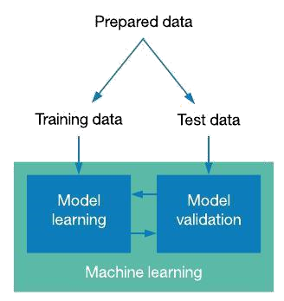

**Fig. 1** Training and testing

**1.3.2. SELECTION OF ATTRIBUTES:**

Selecting the appropriate attributes for a heart disease prediction model is crucial for developing an accurate and reliable machine learning model. It is important to have a good understanding of the domain of heart disease and to consult with medical professionals to identify the most important factors that contribute to heart disease risk. The selected attributes should also be available in the data sources being used, and their importance should be validated through feature selection techniques.

Attribute or Feature selection includes the selection of appropriate attributes for the prediction system. This is used to increase the efficiency of the system. Various attributes of the patient like gender, chest pain type, fasting blood pressure, serum cholesterol, exang, etc are selected for the prediction. The Correlation matrix is used for attribute selection for this model.

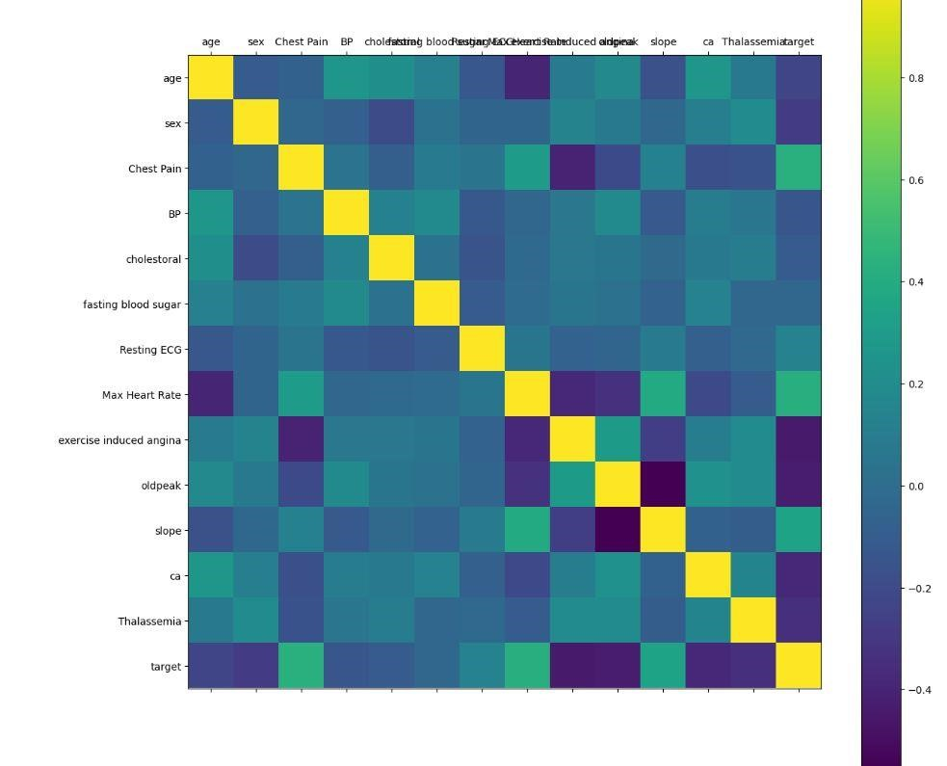

# 3.3PREPROCESSING OF DATA

Data pre-processing is an important step for the creation of a machine learning model. Initially, data may not be clean or in the required format for the model which can cause misleading outcomes. In pre-processing of data, we transform data into our required format. It is used to deal with noises, duplicates, and missing values of the dataset. Data pre-processing has the activities like importing datasets, splitting datasets, attribute scaling, etc. pre-processing of data is required for improving the accuracy of the model.

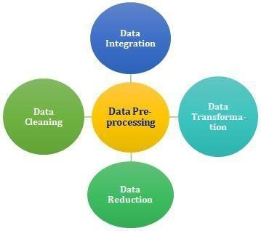

**Fig. 3** Processing of data

## 1.3.4 BALANCING OF DATA

Imbalanced datasets can be balanced in two ways. They are Under Sampling and Over Sampling

(a)Under Sampling: In Under Sampling, dataset balance is done by the reduction of the size of the ample class. This process is considered when the amount of data is adequate.

(b) Over Sampling: In Over Sampling, dataset balance is done by increasing the size of the scarce samples. This process is considered when the amount of data is inadequate.

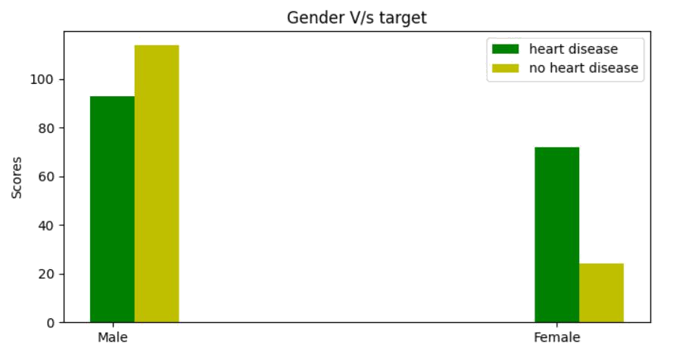

## 1.3.5. MACHINE LEARNING

Machine learning is a subfield of artificial intelligence that focuses on developing algorithms and models that can learn from data and make predictions or decisions based on that learning. The goal of machine learning is to create computer systems that can automatically improve their performance on a given task with experience.

There are several types of machines learning algorithms, including supervised learning, unsupervised learning, semi-supervised learning, and reinforcement learning. In supervised learning, the algorithm is trained on labelled data, which consists of input-output pairs. The algorithm learns to map the input to the output by minimizing a cost function that measures the difference between the predicted output and the actual output. Examples of supervised learning algorithms include linear regression, logistic regression, decision trees, support vector machines, and neural networks.

In unsupervised learning, the algorithm is trained on unlabelled data, and the goal is to identify patterns or structure in the data. The most common unsupervised learning algorithms are clustering algorithms, which group together similar data points based on some similarity metric. Other unsupervised learning algorithms include dimensionality reduction techniques, such as principal component analysis and t-SNE.

Semi-supervised learning is a type of machine learning that uses both labelled and unlabelled data to improve the performance of the algorithm. The labelled data is used to train a model, and the unlabelled data is used to improve the model by making it more robust to variations in the data.

Reinforcement learning is a type of machine learning where an agent learns to interact with an environment to maximize a reward signal. The agent takes actions in the environment, and the environment provides feedback in the form of a reward signal. The agent learns to take actions that maximize the reward over time.

Machine learning has a wide range of applications, including image and speech recognition, natural language processing, recommendation systems, fraud detection, and predictive analytics. In the context of heart disease prediction, machine learning algorithms can be used to predict the risk of heart disease based on patient data, such as demographics, medical history, and clinical test results. The performance of machine learning algorithms can be evaluated through various metrics, such as accuracy, precision, recall, and F1-score. The goal of a heart disease prediction project is to develop a machine learning model that accurately predicts the risk of heart disease in patients, which can help in early diagnosis and prevention of the disease.

* **Supervised Learning**

Supervised learning is the type of machine learning in which machines are trained using well "labelled" training data, and on the basis of that data, machines predict the output.

The labelled data means some input data is already tagged with the correct output.

In supervised learning, the training data provided to the machines work as the supervisor that teaches the machines to predict the output correctly. It applies the same concept as a student learns in the supervision of the teacher.

Supervised learning is a process of providing input data as well as correct output data to the machine learning model. The aim of a supervised learning algorithm is to find a mapping function to map the input variable(x) with the output variable(y).

* **Unsupervised learning**

Unsupervised learning cannot be directly applied to a regression or classification problem because unlike supervised learning, we have the input data but no corresponding output data. The goal of unsupervised learning is to find the underlying structure of dataset, group that data according to similarities, and represent that dataset in a compressed format.

Unsupervised learning is helpful for finding useful insights from the data.

Unsupervised learning is much similar to how a human learns to think by their own experiences, which makes it closer to the real AI.

Unsupervised learning works on unlabeled and uncategorized data which make unsupervised learning more important.

In real-world, we do not always have input data with the corresponding output so to solve such cases, we need unsupervised learning.

• **Reinforcement learning**

Reinforcement learning is an area of Machine Learning. It is about taking suitable action to maximize reward in a particular situation. It is employed by various software and machines to find the best possible behaviour or path it should take in a specific situation. Reinforcement learning differs from supervised learning in a way that in supervised learning the training data has the answer key with it so the model is trained with the correct answer itself whereas in reinforcement learning, there is no answer but the reinforcement agent decides what to do to perform the given task. In the absence of a training dataset, it is bound to learn from its experience.

## 1.3.6. ALGORITHMS

• **SUPPORT VECTOR MACHINE (SVM)**:

Support Vector Machine or SVM is one of the most popular Supervised Learning algorithms, which is used for Classification as well as Regression problems.

However, primarily, it is used for Classification problems in Machine Learning.

The goal of the SVM algorithm is to create the best line or decision boundary that can segregate n-dimensional space into classes so that we can easily put the new data point in the correct category in the future. This best decision boundary is called a hyperplane. SVM chooses the extreme points/vectors that help in creating the hyperplane. These extreme cases are called support vectors, and hence the algorithm is termed as Support Vector Machine.

Support vector machines (SVMs) are powerful yet flexible supervised machine learning algorithms which are used both for classification and regression. But generally, they are used in classification problems. In the 1960s, SVMs were first introduced but later they got refined in 1990. SVMs have their unique way of implementation as compared to other machine learning algorithms. Lately, they are extremely popular because of their ability to handle multiple continuous and categorical variables.

The followings are important concepts in SVM -

Support Vectors - Data Points that are closest to the hyperplane are called support vectors.

Separating line will be defined with the help of these data points.

Hyperplane - As we can see in the above diagram, it is a decision plane or space which is divided between a set of objects having different classes.

Margin - It may be defined as the gap between two lines on the closest data points of different classes. It can be calculated as the perpendicular distance from the line to the support vectors.

Large margin is considered as a good margin and small margin is considered as a bad margin.

**Types of SVM:**

SVM can be of two types:

* **Linear SVM:** Linear SVM is used for linearly separable data, which means ifa dataset can be classified into two classes by using a single straight line, then such data is termed as linearly separable data, and classifier is used called as Linear SVM classifier.

* **Non-linear SVM:** Non-Linear SVM is used for non-linearly separated data,which means if a dataset cannot be classified by using a straight line, then such data is termed as non-linear data and classifier used is called as Non-linear SVM classifier.

The objective of the support vector machine algorithm is to find a hyperplane in an Ndimensional space (N - the number of features) that distinctly classifies the data points.

**The advantages of support vector machines are:**

* Effective in high dimensional spaces.
* Still effective in cases where the number of dimensions is greater than the number of samples.
* Uses a subset of training points in the decision function (called support vectors), so it is also memory efficient.
* Versatile: different [kernel functions ca](https://scikit-learn.org/stable/modules/svm.html#svm-kernels)n be specified for the decision function.
* Common kernels are provided, but it is also possible to specify custom kernels.

**The disadvantages of support vector machines include:**

* If the number of features is much greater than the number of samples, avoid over-fitting in choosing [Kernel functions an](https://scikit-learn.org/stable/modules/svm.html#svm-kernels)d regularization term is crucial.
* SVMs do not directly provide probability estimates, these are calculated using an expensive five-fold cross-validation.

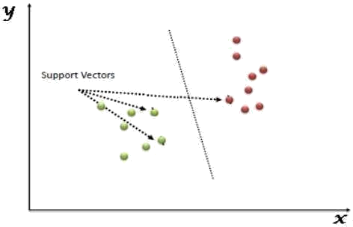

Figure: Support Vector Machine

* **NAIVE BAYES ALGORITHM**:

Naive Bayes algorithm is a supervised learning algorithm, which is based on Bayes theorem and used for solving classification problems. It is mainly used in text classification that includes a high-dimensional training dataset.

Naive Bayes Classifier is one of the simple and most effective Classification algorithms which helps in building the fast machine learning models that can make quick predictions.

It is a probabilistic classifier, which means it predicts on the basis of the probability of an object. Some popular examples of Naïve Bayes Algorithm are spam filtration, Sentimental analysis, and classifying articles.

It is a classification technique based on Bayes’ Theorem with an assumption of independence among predictors. In simple terms, a Naive Bayes classifier assumes that the presence of a particular feature in a class is unrelated to the presence of any other feature.

The Naive Bayes model is easy to build and particularly useful for very large data sets. Along with simplicity, Naive Bayes is known to outperform even highly sophisticated classification methods.

The Naive Bayes algorithm is comprised of two words Naive and Bayes, which can be described as:

* **Naive:** It is called Naive because it assumes that the occurrence of a certainfeature is independent of the occurrence of other features. Such as if the fruit is identified on the basis of color, shape, and taste, then red, spherical, and sweet fruit is recognized as an apple. Hence each feature individually contributes to identify that it is an apple without depending on each other.
* **Bayes:** It is called Bayes because it depends on the principle of Bayes'Theorem.

**Bayes’s theorem:**

Bayes' theorem is also known as Bayes' Rule or Bayes' law, which is used to determine the probability of a hypothesis with prior knowledge. It depends on the conditional probability.

The formula for Bayes' theorem is given as:



Where,

P(A|B) is Posterior probability: Probability of hypothesis A on the observed event B.

P(B|A) is Likelihood probability: Probability of the evidence given that the probability of a hypothesis is true.

P(A) is Prior Probability: Probability of hypothesis before observing the evidence.

P(B) is Marginal Probability: Probability of Evidence.

**Types of Naive Bayes model:**

There are three types of Naive Bayes Model, which are given below:

* **Gaussian:** The Gaussian model assumes that features follow a normaldistribution. This means if predictors take continuous values instead of discrete, then the model assumes that these values are sampled from the Gaussian distribution.
* **Multinomial:** The Multinomial Naïve Bayes classifier is used when the data ismultinomial distributed. It is primarily used for document classification problems, it means a particular document belongs to which category such as Sports, Politics, education, etc. The classifier uses the frequency of words for the predictors.
* **Bernoulli:** The Bernoulli classifier works similar to the Multinomial classifier,but the predictor variables are the independent Booleans variables. Such as if a particular word is present or not in a document. This model is also famous for document classification tasks.

* **DECISION TREE ALGORITHM**

Decision Tree is a Supervised learning technique that can be used for both classification and regression problems, but mostly it is preferred for solving classification problems. It is a treestructured classifier, where internal nodes represent the features of a dataset, branches represent the decision rules and each leaf node represents the outcome. In a Decision Tree, there are two nodes, which are the Decision Node and Leaf Node.

Decision nodes are used to make any decision and have multiple branches, whereas Leaf nodes are the output of those decisions and do not contain any further branches. The decisions or the test are performed on the basis of features of the given dataset. It is a graphical representation for getting all the possible solutions to a problem/decision based on given conditions. It is called a Decision Tree because, similar to a tree, it starts with the root node, which expands on further branches and constructs a tree-like structure. In order to build a tree, we use the CART algorithm, which stands for Classification and Regression Tree algorithm. A Decision Tree simply asks a question, and based on the answer (Yes/No), it further split the tree into subtrees.

The Decision Tree Algorithm belongs to the family of supervised machine learning algorithms.

It can be used for both a classification problem as well as for a regression problem.

The goal of this algorithm is to create a model that predicts the value of a target variable, for which the decision tree uses the tree representation to solve the problem in which the leaf node corresponds to a class label and attributes are represented on the internal node of the tree.

There are various algorithms in Machine learning, so choosing the best algorithm for the given dataset and problem is the main point to remember while creating a machine learning model. Below are the two reasons for using the Decision Tree:

* Decision Trees usually mimic human thinking ability while making a decision, so it is easy to understand.
* The logic behind the decision tree can be easily understood because it shows a tree-like structure.

In Decision Tree the major challenge is to identify the attribute for the root node in each level.

This process is known as attribute selection. We have two popular attribute selection measures:

**1. Information Gain:**

When we use a node in a Decision Tree to partition the training instances into smaller subsets, the entropy changes. Information gain is a measure of this change in entropy.

Entropy is the measure of uncertainty of a random variable, it characterizes the impurity of an arbitrary collection of examples.

The higher the entropy the more the information content.

**2.Gini Index:**

Gini Index is a metric to measure how often a randomly chosen element would be incorrectly identified. It means an attribute with lower Gini index should be preferred. Sklearn supports “Gini” criteria for Gini Index and by default, it takes “gini” value.

The most notable types of Decision Tree algorithms are: -

**3.IDichotomiser 3 (ID3):**

This algorithm uses Information Gain to decide which attribute is to be used to classify the current subset of the data. For each level of the tree, information gain is calculated for the remaining data recursively.

**4.C4.5:** This algorithm is the successor of the ID3 algorithm. This algorithmuses either Information gain or Gain ratio to decide upon the classifying attribute. It is a direct improvement from the ID3 algorithm as it can handle both continuous and missing attribute values.

**Classification and Regression Tree (CART):** It is a dynamic learningalgorithm which can produce a regression tree as well as a classification tree depending upon the dependent variable.

**Working:**

In a Decision Tree, for predicting the class of the given dataset, the algorithm starts from the root node of the tree. This algorithm compares the values of the root attribute with the record (real dataset) attribute and, based on the comparison, follows the branch and jumps to the next node.

For the next node, the algorithm again compares the attribute value with the other sub-nodes and moves further. It continues the process until it reaches the leaf node of the tree. The complete process can be better understood using the below algorithm:

* Step-1: Begin the tree with the root node, says S, which contains the complete dataset.
* Step-2: Find the best attribute in the dataset using Attribute Selection Measure (ASM).
* Step-3: Divide the S into subsets that contains possible values for the best attributes.
* Step-4: Generate the Decision Tree node, which contains the best attribute.
* Step-5: Recursively make new decision trees using the subsets of the dataset created in step –

Continue this process until a stage is reached where you cannot further classify the nodes and call the final node as a leaf node.

* **RANDOM FOREST ALGORITHM**

Random Forest is a supervised learning algorithm. It is an extension of machine learning classifiers which include the bagging to improve the performance of Decision Tree. It combines tree predictors, and trees are dependent on a random vector which is independently sampled. The distribution of all trees is the same. Random Forests splits nodes using the best among of a predictor subset that are randomly chosen from the node itself, instead of splitting nodes based on the variables. The time complexity of the worst case of learning with Random Forests is O (M (dn logn)), where M is the number of growing trees, n is the number of instances, and d is the data dimension.

It can be used both for classification and regression. It is also the most flexible and easy to use algorithm. A forest consists of trees. It is said that the more trees it has, the more robust a forest is. Random Forests create Decision Trees on randomly selected data samples, get predictions from each tree and select the best solution by means of voting. It also provides a pretty good indicator of the feature importance.

Random Forests have a variety of applications, such as recommendation engines, image classification and feature selection. It can be used to classify loyal loan applicants, identify fraudulent activity and predict diseases. It lies at the base of the Boruta algorithm, which selects important features in a dataset.

Random Forest is a popular machine learning algorithm that belongs to the supervised learning technique. It can be used for both Classification and Regression problems in ML. It is based on the concept of ensemble learning, which is a process of combining multiple classifiers to solve a complex problem and to improve the performance of the model.

As the name suggests, "Random Forest is a classifier that contains a number of decision trees on various subsets of the given dataset and takes the average to improve the predictive accuracy of that dataset." Instead of relying on one decision tree, the random forest takes the prediction from each tree and based on the majority votes of predictions, and it predicts the final output. The greater number of trees in the forest leads to higher accuracy and prevents the problem of overfitting.

**Assumptions:**

Since the random forest combines multiple trees to predict the class of the dataset, it is possible that some decision trees may predict the correct output, while others may not. But together, all the trees predict the correct output. Therefore, below are two assumptions for a better Random Forest classifier:

* There should be some actual values in the feature variable of the dataset so that the classifier can predict accurate results rather than a guessed result.
* The predictions from each tree must have very low correlations.

**Algorithm Steps:**

It works in four steps:

* Select random samples from a given dataset.
* Construct a Decision Tree for each sample and get a prediction result from each Decision Tree.
* Perform a vote for each predicted result.
* Select the prediction result with the most votes as the final prediction.

**Advantages:**

* Random Forest is capable of performing both Classification and Regression tasks.
* It is capable of handling large datasets with high dimensionality.
* It enhances the accuracy of the model and prevents the overfitting issue.

**Disadvantages:**

Although Random Forest can be used for both classification and regression tasks, it is not more suitable for Regression tasks.

* **LOGISTIC REGRESSION ALGORITHM**

Logistic regression is one of the most popular Machine Learning algorithms, which comes under the Supervised Learning technique. It is used for predicting the categorical dependent variable using a given set of independent variables.

Logistic regression predicts the output of a categorical dependent variable. Therefore, the outcome must be a categorical or discrete value. It can be either Yes or No, 0 or 1, true or False, etc. but instead of giving the exact value as 0 and 1, it gives the probabilistic values which lie between 0 and 1.

Logistic Regression is much similar to the Linear Regression except that how they are used. Linear Regression is used for solving Regression problems, whereas logistic regression is used for solving the classification problems.

In Logistic regression, instead of fitting a regression line, we fit an "S"shaped logistic function, which predicts two maximum values (0 or 1).

The curve from the logistic function indicates the likelihood of something such as whether the cells are cancerous or not, a mouse is obese or not based on its weight, etc.

Logistic Regression is a significant machine learning algorithm because it has the ability to provide probabilities and classify new data using continuous and discrete datasets.

**Advantages:**

Logistic Regression is one of the simplest machine learning algorithms and is easy to implement yet provides great training efficiency in some cases. Also due to these reasons, training a model with this algorithm doesn't require high computation power.

The predicted parameters (trained weights) give inference about the importance of each feature. The direction of association i.e., positive or negative is also given. So, we can use Logistic Regression to find out the relationship between the features.

This algorithm allows models to be updated easily to reflect new data, unlike Decision Tree or Support Vector Machine. The update can be done using stochastic gradient descent.

Logistic Regression outputs well-calibrated probabilities along with classification results. This is an advantage over models that only give the final classification as results. If a training example has a 95% probability for a class, and another has a 55% probability for the same class, we get an inference about which training examples are more accurate for the formulated problem.

**Disadvantages:**

Logistic Regression is a statistical analysis model that attempts to predict precise probabilistic outcomes based on independent features. On high dimensional datasets, this may lead to the model being over-fit on the training set, which means overstating the accuracy of predictions on the training set and thus the model may not be able to predict accurate results on the test set. This usually happens in the case when the model is trained on little training data with lots of features. So, on high dimensional datasets, Regularization techniques should be considered to avoid overfitting (but this makes the model complex). Very high regularization factors may even lead to the model being under-fit on the training data.

Non-linear problems can't be solved with logistic regression since it has a linear decision surface. Linearly separable data is rarely found in real world scenarios. So the transformation of non-linear features is required which can be done by increasing the number of features such that the data becomes linearly separable in higher dimensions.

**Non-Linearly Separable Data:**

It is difficult to capture complex relationships using logistic regression. More powerful and complex algorithms such as Neural Networks can easily outperform this algorithm

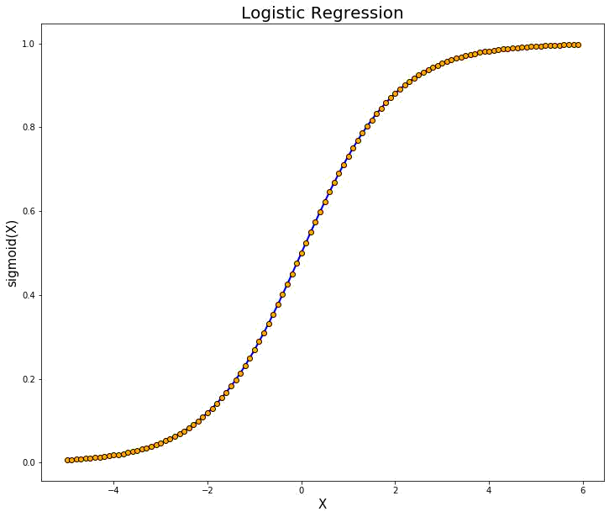

Figure: Logistic Regression

• **ADABOOST ALGORITHM**

Adaboost was the first really successful boosting algorithm developed for the purpose of binary classification. Adaboost is short for Adaptive Boosting and is a very popular boosting technique which combines multiple “weak classifiers” into a single “strong classifier”

Algorithm:

1. Initially, Adaboost selects a training subset randomly.
2. It iteratively trains the Adaboost machine learning model by selecting the training set based on the accurate prediction of the last training.
3. It assigns the higher weight to wrong classified observations so that in the next iteration these observations will get the high probability for classification.
4. Also, it assigns the weight to the trained classifier in each iteration according to the accuracy of the classifier. The more accurate classifier will get high weight.
5. This process iterates until the complete training data fits without any error or until reached to the specified maximum number of estimators.
6. To classify, perform a "vote" across all of the learning algorithms you built.

**Advantages:**

Adaboost has many advantages due to its ease of use and less parameter tweaking when compared with the SVM algorithms. Plus, Adaboost can be used with SVM though theoretically, overfitting is not a feature of Adaboost applications, perhaps because the parameters are not optimized jointly and the learning process is slowed due to estimation stagewise. This link is useful to understand mathematics. The flexible Adaboost can also be used for accuracy improvement of weak classifiers and cases in image/text classification.

**Disadvantages:**

Adaboost uses a progressively learning boosting technique. Hence high-quality data is needed in examples of Adaboost vs Random Forest. It is also very sensitive to outliers and noise in data requiring the elimination of these factors before using the data. It is also much slower than the XG-boost algorithm.

• **XGBOOST ALGORITHM**

XG-boost is an implementation of Gradient Boosted decision trees. It is a type of Software library that was designed basically to improve speed and model performance. In this algorithm, decision trees are created in sequential form. Weights play an important role in XG-boost. Weights are assigned to all the independent variables which are then fed into the decision tree which predicts results. Weight of variables predicted wrong by the tree is increased and these the variables are then fed to the second decision tree. These individual classifiers/predictors then assemble to give a strong and more precise model. It can work on regression, classification, ranking, and user-defined predict.

1. Regularization: XG-boost has in-built L1 (Lasso Regression) and L2 (Ridge

Regression) regularization which prevents the model from overfitting. That is why, XG-boost is also called regularized form of GBM (Gradient Boosting Machine). While using Scikit Learn library, we pass two hyper-parameters (alpha and lambda) to XGboost related to regularization. alpha is used for L1 regularization and lambda is used for L2 regularization.

1. Parallel Processing: XG-boost utilizes the power of parallel processing and that is why it is much faster than GBM. It uses multiple CPU cores to execute the model. While using Scikit Learn library, nthread hyper-parameter is used for parallel processing. nthread represents number of CPU cores to be used. If you want to use all the available cores, don't mention any value for nthread and the algorithm will detect automatically.
2. Handling Missing Values: XG-boost has an in-built capability to handle missing values. When XG-boost encounters a missing value at a node, it tries both the left and right hand split and learns the way leading to higher loss for each node. It then does the same when working on the testing data.
3. Cross Validation: XG-boost allows user to run a cross-validation at each iteration of the boosting process and thus it is easy to get the exact optimum number of boosting iterations in a single run. This is unlike GBM where we have to run a grid-search and only a limited values can be tested.
4. Effective Tree Pruning: A GBM would stop splitting a node when it encounters a negative loss in the split. Thus, it is more of a greedy algorithm. XG-boost on the other hand make splits up to the max. depth specified and then start pruning the tree backwards and remove splits beyond which there is no positive gain.

# LITERATURE REVIEW

A literature review is an essential component of any research project, including a heart disease prediction project. The purpose of a literature review is to provide a comprehensive overview of the existing research and knowledge in a particular field, and to identify gaps and areas for future research.

In the case of a heart disease prediction project, a literature review should focus on the relevant studies and research related to heart disease risk factors, machine learning algorithms for predicting heart disease, and existing heart disease prediction models.

Heart disease is a leading cause of death worldwide, and it is important to identify the factors that contribute to its development in order to prevent and treat the disease. Some of the known risk factors for heart disease include age, gender, family history, high blood pressure, high cholesterol, smoking, obesity, and diabetes.

Several studies have investigated the effectiveness of machine learning algorithms for predicting heart disease. For example, a study by Krittanawong et al. (2017) compared the performance of various machine learning algorithms for predicting heart disease risk using data from the Framingham Heart Study. The study found that the random forest algorithm had the highest predictive accuracy, followed by logistic regression and neural networks.

Another study by Xiong et al. (2020) used machine learning algorithms to predict the risk of heart disease in Chinese adults based on data from the China Health and Nutrition Survey. The study found that the decision tree algorithm had the highest predictive accuracy, followed by the support vector machine algorithm.

Existing heart disease prediction models, such as the Framingham Heart Study and the European Systematic Coronary Risk Evaluation (SCORE) model, have also been extensively studied in the literature. A study by D'Agostino et al. (2008) evaluated the performance of the Framingham Heart Study model in predicting cardiovascular disease risk in a multiethnic cohort. The study found that the model had good predictive accuracy in white and black participants, but performed poorly in Hispanic and Asian participants.

In addition to evaluating existing models and algorithms, some studies have focused on developing new models for heart disease prediction. For example, a study by Dey et al. (2019) developed a novel deep learning-based model for predicting heart disease risk using electronic health record data. The study found that the deep learning model had higher predictive accuracy than existing models.

Overall, the literature review highlights the importance of identifying relevant risk factors for heart disease, and using machine learning algorithms to develop accurate and reliable heart disease prediction models. However, further research is needed to validate these models in diverse populations and to identify novel risk factors that can improve the accuracy of these models.

Additionally, the literature review also highlights the importance of data quality and preprocessing in developing accurate machine learning models for heart disease prediction. Many studies have emphasized the need for careful data cleaning, missing value imputation, and feature selection to ensure that only relevant and high-quality data is used for model training.

Furthermore, the literature review also points towards the importance of model interpretability, particularly in the context of medical applications. Many machine learning algorithms, such as neural networks and support vector machines, are often considered "black boxes" due to their complex inner workings, which can make it difficult to understand how and why they make specific predictions. Interpretable models, such as decision trees and logistic regression models, can provide valuable insights into the factors that contribute to heart disease risk and can help healthcare professionals develop targeted interventions to prevent and treat the disease.

Finally, the literature review also highlights the potential ethical and social implications of using machine learning algorithms for heart disease prediction. For example, there are concerns about privacy and data security when collecting and analysing sensitive health information. Additionally, there are concerns about potential biases in algorithmic predictions, particularly if the models are trained on biased data or if they reinforce existing societal disparities.

In conclusion, the literature review provides valuable insights into the existing research and knowledge related to heart disease prediction using machine learning algorithms. By synthesizing and critically evaluating the relevant literature, the literature review can help guide the design and implementation of the heart disease prediction project, and identify areas for further research and development.

# PROBLEM STATEMENT

Heart disease is a major public health issue that affects millions of people worldwide. Despite significant advances in medical research and treatment, heart disease remains a leading cause of death and disability, and identifying the risk factors that contribute to the development of the disease is essential for effective prevention and treatment.

Traditional approaches to heart disease risk assessment typically involve assessing the patient's age, gender, family history, and lifestyle factors such as smoking, exercise, and diet. While these factors can provide useful information about a patient's risk for heart disease, they may not be sufficient to accurately predict individual risk.

Recent studies have demonstrated that machine learning algorithms can improve the accuracy of heart disease risk prediction by incorporating a wider range of risk factors and using complex statistical models to identify patterns and relationships in the data. Machine learning algorithms can also be adapted to individual patients based on their unique risk factors, providing a more personalized and targeted approach to prevention and treatment.

However, despite the potential benefits of machine learning for heart disease prediction, there are several challenges that must be addressed in order to develop accurate and reliable models. One of the main challenges is data quality and availability. High-quality data is essential for machine learning algorithms to accurately predict heart disease risk, but collecting and curating large amounts of high-quality data can be time-consuming and resource-intensive. Additionally, there may be issues with missing data or data inconsistencies that need to be addressed before the data can be used for analysis.

Another challenge is the selection of appropriate machine learning algorithms and model parameters. There are many different types of machine learning algorithms, each with its own strengths and weaknesses, and selecting the most appropriate algorithm and model parameters for a specific dataset and research question can be a complex and iterative process. Furthermore, the results of machine learning algorithms can sometimes be difficult to interpret, making it challenging to identify which risk factors are most important for predicting heart disease risk.

A further challenge is the potential for bias in machine learning algorithms. Machine learning algorithms are only as good as the data they are trained on, and if the data is biased, the resulting models may also be biased. Bias can occur if the data used to train the algorithms is not representative of the population being studied, or if the algorithms are unintentionally reinforcing existing societal biases or inequalities.

Finally, there are ethical and social implications associated with using machine learning algorithms for heart disease prediction. Privacy and data security are major concerns when collecting and analysing sensitive health information, and patients may be hesitant to provide their data for fear of it being misused or shared without their consent. Additionally, there is a risk that machine learning algorithms may be used to discriminate against certain individuals or populations, particularly if the algorithms reinforce existing biases or inequalities.

In light of these challenges, the problem statement for the heart disease prediction project is to develop and evaluate machine learning algorithms that can accurately predict individual risk of heart disease, while addressing issues related to data quality, algorithm selection, bias, and ethical and social implications. The project aims to improve the accuracy of heart disease risk prediction and provide a more personalized and targeted approach to prevention and treatment, while also addressing the broader societal and ethical implications of using machine learning in healthcare.

To address the problem statement, the heart disease prediction project will focus on several key research questions:

1. What are the most important risk factors for heart disease, and how can these risk factors be identified and measured?
2. What machine learning algorithms are most effective for predicting heart disease risk, and how can the performance of these algorithms be evaluated and compared?
3. How can bias and fairness be addressed in machine learning algorithms for heart disease prediction, and what are the ethical and social implications of using these algorithms in clinical practice?

To answer these research questions, the heart disease prediction project will collect and curate a large dataset of patient health records, including demographic information, lifestyle factors, medical history, and clinical test results. The project team will then use data cleaning and preprocessing techniques to ensure the data is high-quality and consistent, and will select appropriate machine learning algorithms and model parameters to develop predictive models.

The performance of these models will be evaluated using standard metrics such as accuracy, precision, recall, and area under the curve (AUC), and the models will be compared against existing risk assessment tools such as the Framingham Risk Score. The project team will also conduct sensitivity analyses to determine how robust the models are to changes in the input data, and will evaluate the models for bias and fairness using techniques such as group fairness metrics and causal inference.

Finally, the project team will consider the ethical and social implications of using machine learning algorithms for heart disease prediction, including issues related to data privacy and security, informed consent, and algorithmic bias. The team will engage with stakeholders such as patients, healthcare providers, and policymakers to ensure that the project's findings are grounded in real-world needs and concerns, and will develop recommendations for how machine learning algorithms can be used in a responsible and equitable manner.

In summary, the heart disease prediction project aims to develop and evaluate machine learning algorithms that can improve the accuracy of heart disease risk prediction, while addressing issues related to data quality, algorithm selection, bias, and ethical and social implications. By providing a more personalized and targeted approach to prevention and treatment, the project has the potential to improve patient outcomes and reduce the burden of heart disease on individuals and society as a whole.

# SYSTEM ANALYSIS

System analysis is a crucial step in the heart disease prediction project, as it involves understanding the requirements and constraints of the system, and identifying the various components and processes involved in the project. The system analysis phase will involve defining the scope of the project, identifying the stakeholders and their needs, and specifying the functional and non-functional requirements of the system. This will be done through interviews with healthcare providers, patients, and other stakeholders, as well as a review of existing literature and risk assessment tools. The project team will also identify the various data sources and systems that will be used in the project, and will evaluate the compatibility and interoperability of these systems. By conducting a thorough system analysis, the project team can ensure that the heart disease prediction system is designed and implemented in a way that meets the needs of stakeholders, is efficient and effective, and adheres to ethical and regulatory standards.

**4.1. IDENTIFICATION OF NEED**

The identification of need is a critical step in any project, and the heart disease prediction project is no exception. The need for this project arises from several factors, including the high prevalence and impact of heart disease, the limitations of existing risk assessment tools, and the potential benefits of using machine learning algorithms to improve the accuracy and personalization of risk prediction.

Heart disease is a leading cause of death worldwide, with an estimated 17.9 million deaths per year. In addition to the human toll, heart disease also has a significant economic impact, with direct and indirect costs estimated at over $200 billion per year in the United States alone. Despite advances in prevention and treatment, heart disease remains a major public health challenge.

Existing risk assessment tools, such as the Framingham Risk Score, have been shown to be effective in predicting heart disease risk, but they have limitations in terms of accuracy and personalization. These tools rely on a limited number of risk factors, such as age, sex, smoking status, and cholesterol levels, and may not account for other factors that could impact risk, such as genetics, lifestyle, and comorbidities. As a result, some individuals may be incorrectly classified as low or high risk, leading to under- or over-treatment.

Machine learning algorithms have the potential to address these limitations by incorporating a wider range of risk factors and using sophisticated modelling techniques to improve accuracy and personalization. By developing and evaluating these algorithms, the heart disease prediction project aims to provide a more comprehensive and accurate approach to risk assessment, which could lead to better prevention and treatment strategies and improved patient outcomes.

In summary, the need for the heart disease prediction project arises from the high prevalence and impact of heart disease, the limitations of existing risk assessment tools, and the potential benefits of using machine learning algorithms to improve risk prediction. By addressing this need, the project has the potential to make a significant contribution to the field of cardiovascular disease prevention and treatment.

Additionally, the need for this project is also driven by the increasing availability of electronic health records (EHRs) and other health data sources, which provide a wealth of information that can be leveraged for risk prediction. However, the vast amounts of data available can be overwhelming and difficult to analyse using traditional statistical methods. Machine learning algorithms, which are well-suited to handling large and complex datasets, can help to extract insights from this data and improve risk prediction.

Furthermore, the personalized and accurate risk assessment provided by the heart disease prediction project can also contribute to the development of precision medicine, which is an emerging field that aims to tailor medical treatments to the unique characteristics of individual patients. By identifying individuals at high risk of heart disease, healthcare providers can target prevention and treatment strategies to those who are most likely to benefit, while avoiding unnecessary interventions in low-risk individuals. This personalized approach could lead to improved patient outcomes and reduced healthcare costs.

Overall, the heart disease prediction project addresses a critical need for more accurate and personalized risk assessment in the context of cardiovascular disease. By incorporating machine learning algorithms and leveraging the wealth of data available, the project has the potential to make a significant contribution to the prevention and treatment of heart disease, and to the development of precision medicine more broadly.

**4.2. PRELIMINARY INVESTIGATION**

**Background and context of the project:**

Provide an overview of the heart disease prediction project, its purpose, and its importance to the organization.

**Data sources**:

Identify the data sources that will be used in the heart disease prediction project. Evaluate the quality and completeness of the data and determine if any additional data sources are required.

**Machine learning algorithms:**

Identify and evaluate the machine learning algorithms that will be used in the heart disease prediction project. Determine the most appropriate algorithms and models for the project and assess their performance.

**Stakeholder analysis:**

Identify the stakeholders of the project and analyse their requirements and expectations. Determine the scope of the project and identify the key features and functionalities that are required to meet the stakeholders' needs. Identify the risks and challenges associated with the project and develop a risk management plan to mitigate these risks.

**Project plan:**

Develop a detailed project plan that outlines the goals, objectives, scope, timeline, budget, and resources required for the heart disease prediction project. The project plan should also include a detailed risk management plan and a plan for project monitoring and evaluation.

Preliminary investigation phase is critical to ensure that the heart disease prediction project is feasible, necessary, and aligned with the organization's goals and objectives. The information gathered during this phase will be used to develop a project plan and a detailed project scope, which will guide the development and implementation of the heart disease prediction system.

**4.3. FEASIBILITY STUDY**

A feasibility study is a critical aspect of any project and is used to determine the practicality and viability of the project. In the context of the heart disease prediction project, a feasibility study is necessary to evaluate the technical, economic, and operational aspects of the project.

Here are some key points to consider in the feasibility study:

1. Technical feasibility: One of the primary concerns in the feasibility study is whether the project is technically feasible. In the case of the heart disease prediction project, the technical feasibility revolves around the availability and quality of the data sources and the machine learning algorithms used to develop the prediction models. The project team needs to evaluate the data sources to determine if they are suitable for the project and if any additional data sources are required. Additionally, the team must determine the appropriate machine learning algorithms and models to use and assess their accuracy in predicting heart disease risk.
2. Economic feasibility: Another critical aspect of the feasibility study is the economic feasibility of the project. The project team needs to assess the resources required to develop and deploy the machine learning models, including the computing infrastructure, software, and personnel. They must also evaluate the potential return on investment (ROI) of the project and determine if it is financially viable for the organization.
3. Operational feasibility: The operational feasibility of the project refers to its ability to integrate with existing systems and processes within the organization. The project team needs to evaluate the impact of the heart disease prediction system on existing systems and processes and determine if any modifications or upgrades are required. They must also assess the user adoption and training requirements for the new system and ensure that the system can be implemented and maintained in a sustainable manner.
4. Risk analysis: A critical aspect of the feasibility study is to identify and analyse the risks associated with the heart disease prediction project. The project team needs to conduct a risk analysis to identify potential risks and develop a risk management plan to mitigate those risks. The risk analysis should include both technical and non-technical risks, such as data privacy and security, system failure, and stakeholder resistance.
5. Ethical considerations: The heart disease prediction project involves collecting and analysing sensitive health data, and therefore, it is essential to consider the ethical implications of the project. The project team needs to ensure that they comply with all relevant laws and regulations related to data privacy and security. They must also consider the potential ethical implications of using machine learning algorithms to predict heart disease risk and ensure that the project aligns with the organization's ethical standards.

Overall, a feasibility study is critical to ensure that the heart disease prediction project is viable and aligns with the organization's goals and objectives. The information gathered during the feasibility study will be used to develop a detailed project plan and budget, which will guide the implementation of the heart disease prediction system. By conducting a thorough feasibility study, the project team can ensure that the heart disease prediction system is successful and meets the needs of the organization and its stakeholders.

**4.4. PROJECT PLANNING**

Project planning is a crucial step in the heart disease prediction project and involves developing a detailed plan that outlines the scope, timelines, budget, resources, and deliverables of the project. Here are some key points to consider in project planning:

1. Define the project scope: The project scope defines the boundaries of the project and specifies what is included and excluded. It is important to clearly define the project scope to ensure that everyone involved in the project understands the project's goals and objectives.
2. Develop a project plan: The project plan is a document that outlines the steps required to complete the project. The project plan should include a timeline, milestones, deliverables, and dependencies.
3. Establish project timelines: The project timeline specifies when each task should be completed and how long it should take. It is essential to establish realistic timelines to ensure that the project is completed on time and within budget.
4. Determine project budget: The project budget outlines the estimated costs of the project, including hardware, software, personnel, and other expenses. It is essential to determine the project budget at the outset of the project to ensure that resources are allocated appropriately.
5. Identify project resources: The project team needs to identify the resources required to complete the project, including personnel, hardware, software, and other resources. The team should also identify any external resources that may be required, such as consultants or contractors.
6. Establish project governance: The project governance framework outlines the roles and responsibilities of project stakeholders, including the project manager, project team, and other stakeholders. It is important to establish a clear governance framework to ensure that the project is managed effectively and that all stakeholders are aware of their roles and responsibilities.
7. Define project risks: The project team needs to identify and assess the risks associated with the project, including technical, financial, and operational risks. The team should develop a risk management plan to mitigate the risks identified.
8. Establish project communication plan: The project communication plan outlines how project stakeholders will communicate with each other and how project progress will be reported. The communication plan should also include escalation procedures in case of issues or challenges.
9. Develop project documentation: The project documentation includes all project-related documents, including the project plan, budget, timelines, and risk management plan. It is essential to maintain accurate and up-to-date project documentation to ensure that the project is managed effectively.

Overall, project planning is a critical step in the heart disease prediction project and is essential to ensure that the project is completed on time, within budget, and to the satisfaction of all stakeholders. By developing a comprehensive project plan, the project team can effectively manage the project and ensure that it meets the goals and objectives of the organization.

**4.5. SOFTWARE REQUIREMENT SPECIFICATION (SRS):**

The Software Requirements Specification (SRS) is a document that outlines the requirements for a software project. In the case of the heart disease prediction project, the SRS would define the functional and non-functional requirements for the software system that would predict the risk of heart disease. Here are the key components of an SRS:

**Introduction:** The introduction provides an overview of the SRS document, including its purpose, scope, and intended audience. It also provides a brief overview of the heart disease prediction project and the software system that will be developed.

**4.5.1. PURPOSE**

The purpose of the Software Requirements Specification (SRS) document is to clearly and unambiguously define the functional and non-functional requirements of the ML-based heart disease diagnosis system. The document serves as a reference for developers, testers, and stakeholders involved in the project, providing a clear understanding of what the system is supposed to do and how it should perform.

The SRS document outlines the specific features and functionalities of the system, as well as the constraints, assumptions, and risks associated with its development and deployment. It also defines the quality attributes that the system should exhibit, such as performance, reliability, usability, and security.

By clearly defining the requirements and quality attributes of the system, the SRS document helps to minimize misunderstandings and miscommunications among team members and stakeholders. It provides a basis for evaluating the system's performance and functionality, and helps to ensure that the system meets the needs and expectations of its users.

Overall, the purpose of the SRS document is to serve as a blueprint for the development of a high-quality and reliable ML-based heart disease diagnosis system, and to ensure that all team members and stakeholders have a clear understanding of the system's requirements and constraints.

**4.5.2 SCOPE**

The scope of this ML-based heart disease diagnosis project is to develop a software system that can accurately diagnose heart disease based on patient data, including medical history, symptoms, and test results. The system will use machine learning algorithms to analyze the data and provide a diagnosis, along with an explanation of the underlying factors that contributed to the diagnosis. The project will include the development of a user-friendly interface for clinicians to input patient data and view diagnostic results. The system will be designed to meet the non-functional requirements outlined in the SRS document, including performance, scalability, reliability, security, usability, maintainability, and ethical considerations.

**Functional requirements:**

Functional requirements for the heart disease project can be defined as the specific features and capabilities that the ML model should possess in order to effectively detect and diagnose heart disease. These functional requirements can be broken down into the following categories:

1. Data Collection and pre-processing: The ML model should be able to collect patient data from various sources, such as electronic health records and medical devices, and pre-process the data to ensure accuracy and consistency. This includes tasks such as data cleaning, normalization, and feature selection.
2. ML Model Development: The ML model should be developed using a range of techniques, such as logistic regression, decision trees, random forests, support vector machines, and neural networks, to analyse patient data and predict the presence of heart disease. The model should also use feature selection techniques and ensemble methods to improve accuracy and robustness.
3. Model Training and Validation: The ML model should be trained on large datasets of patient data to ensure accuracy and effectiveness. The model should also be validated using appropriate metrics, such as sensitivity, specificity, and accuracy, to ensure that it can effectively detect and diagnose heart disease.
4. Integration and Deployment: The ML model should be integrated into existing healthcare systems, such as electronic health record systems, and deployed in clinical settings. The model should also be able to handle real-time data input and provide results quickly and accurately.
5. Maintenance and Updates: The ML model should be regularly maintained and updated to ensure that it remains effective and accurate over time. This includes tasks such as monitoring performance metrics, updating training data, and incorporating new features and capabilities.

The functional requirements for the heart disease project involve collecting and pre-processing patient data, developing an effective ML model, training and validating the model, integrating and deploying the model into existing healthcare systems, and maintaining and updating the model over time. By meeting these requirements, the ML model can effectively detect and diagnose heart disease, leading to improved patient outcomes and reduced healthcare costs.

**Non-functional requirements:**

Non-functional requirements refer to the aspects of a software system that do not relate to its specific functionalities, but rather to its overall performance, security, usability, and other quality attributes. In the context of a heart disease ML project, the following non-functional requirements should be considered:

1. Performance: The ML model should be able to process large datasets efficiently and provide accurate diagnoses within a reasonable timeframe. The system should also be able to handle concurrent requests from multiple users without experiencing significant performance degradation.
2. Scalability: The system should be designed to scale up or down as needed, depending on the volume of data and the number of users. It should be able to handle increased loads without impacting the performance or stability of the system.
3. Reliability: The ML model should be reliable and consistent in its diagnoses. The system should also be able to handle errors and failures gracefully, such as network interruptions, data corruption, or hardware failures.
4. Security: The system should be designed with appropriate security measures to protect patient data and prevent unauthorized access or tampering. This includes encryption of data in transit and at rest, authentication and authorization mechanisms, and audit trails for tracking system activity.
5. Usability: The system should be designed with a user-friendly interface that is easy to navigate and understand, even for non-technical users. It should also provide clear and concise diagnostic results and explanations to help clinicians make informed decisions.
6. Maintainability: The system should be designed with modular and well-documented code to facilitate maintenance and updates. It should also provide tools for monitoring and troubleshooting the system, such as logs, alerts, and performance metrics.
7. Ethical considerations: The system should comply with ethical and legal standards related to the use of patient data, such as HIPAA regulations in the US. It should also be designed to avoid biases and promote fairness in the diagnosis process, especially for underrepresented or marginalized groups.

In summary, the non-functional requirements for a heart disease ML project are essential for ensuring the performance, security, usability, and ethical considerations of the system. These requirements should be carefully considered and documented throughout the software development lifecycle to ensure a high-quality and reliable system that meets the needs of its users.

**4.5.3 OVERALL DESCRIPTION**

The ML-based heart disease diagnosis system is a software application that uses machine learning algorithms to analyse patient data and provide an accurate diagnosis of heart disease. The system will be designed with a user-friendly interface for clinicians to input patient data and view diagnostic results. It will be scalable, reliable, and secure, with appropriate ethical considerations in place to protect patient privacy and promote fairness in the diagnosis process. The system will be designed to meet the functional and non-functional requirements outlined in the SRS document, and will be tested and validated to ensure its accuracy and reliability.

**4.5.4. SYSTEM REQUIREMENTS**

The system must be capable of acquiring, pre-processing, and integrating important data from several sources.

The system should be user-friendly, scalable, flexible, secure, and well-documented, all while adhering to the project's deadline and budgetary constraints.

**4.5.4.1.USER REQUIREMENTS**

1. The system should be easy to use and navigate, with a simple and intuitive interface that requires minimal training for clinicians.
2. The system should provide diagnostic results quickly, with minimal delay or latency.
3. The system should provide clear and accurate explanations of the diagnostic results, including the relevant features and contributing factors.
4. The system should allow clinicians to easily input patient data from various sources, including electronic health records, lab results, and other medical data.
5. The system should provide visualizations and other aids to help clinicians interpret and understand the diagnostic results.
6. The system should allow clinicians to modify and adjust the input data and algorithm parameters to improve diagnostic accuracy.
7. The system should be reliable and consistent in its diagnoses, with a low error rate.
8. The system should protect patient privacy and confidentiality, and comply with ethical and legal standards for the use of patient data.
9. The system should be able to handle a large volume of patient data and requests from multiple users simultaneously.
10. The system should be scalable and adaptable to changes in the underlying data or algorithms over time.

**4.5.4. SOFTWARE REQUIREMENTS**

1. A programming language and framework for building the ML models, such as Python and scikit-learn.
2. Libraries and tools for data pre-processing and feature engineering, such as Pandas and NumPy.
3. Tools for data visualization, such as Matplotlib and Seaborn.
4. Tools for testing and validating the system, such as pytest and hypothesis.
5. Software development methodologies and practices, such as Agile or Scrum.

**4.5.5. INTRODUCTION TO PYTHON: -**

Python is an interpreted, high-level, general-purpose programming language. Python is simple and easy to read syntax emphasizes readability and therefore reduces system maintenance costs. Python supports modules and packages, which promote system layout and code reuse. It saves space but it takes slightly higher time when its code is compiled. Indentation needs to be taken care while coding.

Python does the following:

* + Python can be used on a server to create web applications.
  + It can connect to database systems.
  + It can also read and modify files.
  + It can be used to handle big data and perform complex mathematics.
  + It can be used for production-ready software development.

Python has many inbuilt library functions that can be used easily for working with machine learning algorithms. All the necessary python libraries must be pre-installed using “pip” command.

**4.5.5. PYTHON LIBRARIES: -**

**Numpy: -**

NumPy is a general-purpose array-processing package. It provides a high-performance multidimensional array object, and tools for working with these arrays. It is the fundamental package for scientific computing with Python.

It contains various features including these important ones:

* A powerful N-dimensional array object
* Sophisticated (broadcasting) functions
* Tools for integrating C/C++ and Fortran code
* Useful linear algebra, Fourier transform, and random number capabilities. Besides its obvious scientific uses, NumPy can also be used as an efficient multi-dimensional container of generic data.
  1. Multi-dimensional arrays: NumPy arrays can have multiple dimensions, making it easy to work with large datasets.
  2. Broadcasting: NumPy allows for mathematical operations to be performed on arrays of different sizes and shapes, making it easy to write vectorized code.
  3. Array manipulation: NumPy provides a number of functions for manipulating arrays, such as reshaping, slicing, and indexing.
  4. Mathematical functions: NumPy provides a large number of mathematical functions, including trigonometric functions, logarithmic functions, and statistical functions.
  5. Linear algebra: NumPy provides a number of linear algebra functions, such as matrix multiplication, eigenvalues, and eigenvectors.

Overall, NumPy is an essential library for anyone working with numerical data in Python, as it provides fast and efficient tools for handling and analysing data.

**Pandas**

Pandas is an open-source library that is built on top of NumPy library. It is a Python package that offers various data structures and operations for manipulating numerical data and time series. It is fast and it has high-performance & productivity for users. It provides highperformance and is easy-to-use data structures and data analysis tools for the Python language. Pandas is used in a wide range of fields including academic and commercial domains including economics, Statistics, analytics, etc.

**Matplotlib**

Matplotlib is a popular data visualization library for Python. It provides a wide range of plotting tools and customization options for creating publication-quality charts, graphs, and plots from data.

**Seaborn**

Seaborn is a Python data visualization library based on matplotlib. It provides a high-level interface for creating informative and attractive statistical graphics, including heatmaps, line plots, scatter plots, and more.

**4.5.6. HARDWARE REQUIREMENTS**

* RAM: 4 Gb – 8Gb
* Storage: 500Gb - 1Tb
* Processor: i3 (7th gen)

**4.6. SOFTWARE ENGINEERING PARADIGM APPLIED**

Software engineering paradigms can be applied to a heart disease ML project to ensure the development of a reliable and efficient system. These paradigms are essentially approaches or frameworks that guide software development teams in the creation of software products. They can be used to improve the quality, maintainability, and efficiency of software, while also reducing development time and costs.

One of the most popular software engineering paradigms is agile development. This approach emphasizes collaboration, flexibility, and iterative development. The agile development process involves breaking down the development process into smaller increments, called sprints, which are typically two to four weeks long. Each sprint involves the development of a small set of features or functionality that can be tested and delivered to the customer.

Another important paradigm in software engineering is object-oriented programming (OOP). OOP is a programming paradigm that models the system as a set of interacting objects, each with its own data and behavior. This approach can help to improve code organization, maintainability, and extensibility.

Test-driven development (TDD) is another important software engineering paradigm that can be applied to a heart disease ML project. This approach involves writing automated tests before writing the actual code. The tests are used to define the functionality of the system and to ensure that it functions as expected. TDD can help to catch defects early in the development process and ensure that the system meets its functional requirements.

Continuous integration and deployment (CI/CD) are a paradigm that can be used to automate the building, testing, and deployment of the system. This approach involves using automated tools to build and test the system, and then automatically deploying it to production. CI/CD can help to ensure that changes are integrated and tested in a timely and consistent manner.

Model-View-Controller (MVC) is another software engineering paradigm that can be applied to a heart disease ML project. This approach involves separating the system's data, presentation, and control logic into distinct components. This can help to improve code organization, maintainability, and testability.

Other software engineering paradigms that may be applicable to a heart disease ML project include the Waterfall model, which involves a linear approach to software development; the Spiral model, which involves a more iterative and risk-based approach; and the RAD (Rapid Application Development) model, which emphasizes rapid prototyping and user feedback.

Overall, the application of software engineering paradigms in a heart disease ML project can help to ensure that the system is developed in a systematic and efficient manner, and that it meets the needs and expectations of its users. By using these paradigms, software development teams can improve the quality and maintainability of the system, reduce development time and costs, and ensure that the system functions as expected.

**4.6.1. REQUIREMENT GATHERING**

Requirement gathering for an ML-based heart disease diagnosis system can involve the following steps:

* Identify the business problem to be solved, which is accurate and efficient diagnosis of heart disease to improve patient outcomes and reduce healthcare costs.
* Gather input from stakeholders, including healthcare professionals such as cardiologists and nurses, data analysts, and patients, to understand their requirements and expectations for the system.

Document the functional and non-functional requirements of the heart disease diagnosis system, which can include:

* Data sources: The system should be able to collect patient data from various sources, including electronic health records, lab results, and medical imaging data.
* Diagnostic performance metrics: The system should be able to accurately diagnose different types of heart disease with high sensitivity and specificity, as well as provide explanations of the contributing factors.
* User interface specifications: The system should have a user-friendly interface that is easy to navigate and understand for healthcare professionals with varying levels of technical expertise.
* System scalability: The system should be able to handle a large volume of patient data and requests from multiple users simultaneously, without compromising accuracy or speed.
* System reliability: The system should be reliable and consistent in its diagnoses, with a low error rate.
* System security and privacy: The system should protect patient privacy and confidentiality, and comply with ethical and legal standards for the use of patient data.
* System maintainability and adaptability: The system should be easy to maintain and update as needed, with clear documentation and support for future updates.
* System testing and validation: The system should be rigorously tested and validated to ensure accuracy and reliability.

**4.6.2. DESIGN: -**

* Create high-level and low-level design documents that outline the architecture and design of the system.
* Define the data flow, system components, and interfaces.
* Choose the appropriate technologies, tools, and algorithms for implementing the prediction system, such as machine learning algorithms, data pre-processing techniques, and programming languages.

**4.6.3. DEVELOPMENT: -**

* Implement the system functionality based on the design documents and coding standards.
* Develop machine learning models using the chosen algorithms and libraries.
* Implement data pre-processing and feature engineering techniques to prepare the data for model training and prediction.
* Integrate system components, such as user interfaces, data storage, and model deployment.

**4.6.4. TESTING: -**

* Conduct various types of testing, to validate the system's functionality and performance.
* Identify and fix any defects or issues discovered during testing to ensure the system's accuracy, reliability, and robustness.

**4.6.5. DEPLOYMENT: -**

* Deploy the system in a production environment, which may involve installing the system on a production server, configuring it for live data processing, and setting up monitoring and logging mechanisms.
* Ensure the system is ready for use by end-users, and provide necessary documentation and training for system operation.

**4.6.6. OPERATION AND MAINTENANCE:**

* Monitor the system's performance on an ongoing basis to ensure that it is functioning correctly and providing accurate predictions. This may involve tracking metrics such as accuracy, precision, recall, and F1 score.
* Provide ongoing support and maintenance to the system, including fixing bugs, addressing performance issues, and updating the system with new features and data as necessary.
* Continuously update and refine the system based on feedback from stakeholders and end-users. This may involve adding new features, refining the existing features, or retraining the model with new data to improve its performance.

In terms of software development methodology, an iterative approach such as Agile is suitable for the operation and maintenance of the heart disease prediction system. These methodologies emphasize continuous development and improvement, and can facilitate the ongoing refinement of the system based on feedback and performance metrics.

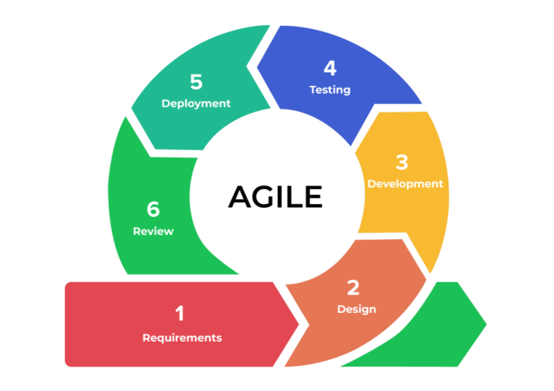

# SYSTEM DESIGN & SPECIFICATIONS

**5.1. DATA FLOW DIAGRAM (DFD): -**

A data flow diagram (DFD) is a graphical representation of the flow of data through a system, depicting how data is input, processed, stored, and output in a system or a process. It is a powerful tool used in systems analysis and design to model and understand the flow of data and information in a system, helping to identify and analyze data sources, processes, and outputs.

The main components of a DFD are data sources, processes, data stores, and data flows. Data sources represent the external entities that provide data to the system or process, such as users, sensors, or other systems. Processes represent the activities or functions that transform input data into output data. Data stores represent the repositories where data is stored and retrieved. Data flows represent the movement of data between data sources, processes, and data stores.

DFDs are typically created using symbols and arrows to represent the various components and their relationships. The symbols used in DFDs include circles for data sources, rectangles for processes, double lines for data stores, and arrows for data flows. Arrows indicate the direction of data flow, showing how data moves from one component to another.

DFDs can be classified into different levels or levels of abstraction, ranging from the highest level (Level 0 or Context Diagram) that provides an overview of the entire system, to lower levels (Level 1, Level 2, etc.) that provide more detailed views of specific processes or subsystems. DFDs can also be used to model different perspectives of a system, such as the current state (as-is) or the desired state (to-be) of a system.

One of the main benefits of using DFDs is that they provide a visual representation of the flow of data in a system, making it easier to understand and communicate the interactions between different components. DFDs can help identify data redundancies, inefficiencies, and potential bottlenecks in a system, allowing for improved system design and optimization. DFDs are also useful for documenting system requirements, designing data interfaces, and identifying potential areas for system improvement or automation.

Overall, data flow diagrams are valuable tools in systems analysis and design for modelling and understanding the flow of data in a system or process. They provide a clear and visual representation of data movement, helping stakeholders to better understand, analyse, and communicate the flow of data in a system or process.

**1 Level 0 data flow diagram: -**

A Level 1 Data Flow Diagram (DFD) is a high-level representation of the flow of data within a system or process, showing the main data inputs, outputs, and processes at a high level of abstraction. It provides an overview of the system's data flow and interactions between its components, without going into detailed internal processes.The Level 1 DFD shows the how the system is divided into sub systems each of which deals with one or more of the data flows to or from an external agent, and which together provide full all functionality of system as a whole.

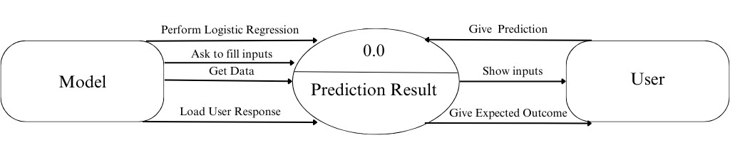

Figure: Level-0 data flow diagram shows how system is divided into sub system

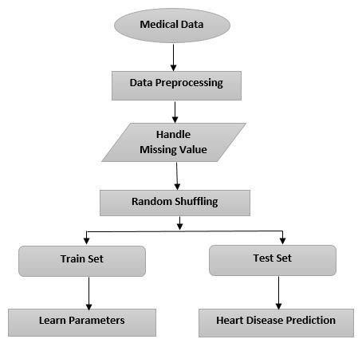

Figure: Level 1 data flow diagram shows the sub process of first

**5.2. ENTITY RELATIONSHIP MODEL**

Entity Relationship (ER) modelling is an essential part of the software development process, especially during the design phase. ER modelling aids in the representation of data needs and entity relationships in a clear and unambiguous manner. It illustrates the data and how various data items relate to one another, allowing developers to build and construct the database schema and software architecture based on those needs.

ER modelling helps in ensuring that all data entities are recognised and documented in a clear and intelligible manner, as well as that their connections are well-defined. It additionally helps in identifying any inconsistencies or errors in the data model prior to database or software installation. ER modelling is an important part of the development process since it assists in the design of efficient, resilient, and scalable systems capable of handling massive volumes of data while ensuring data integrity and consistency.

An Entity-Relationship (ER) diagram is a visual representation of the entities and their relationships in a database. It's a modelling tool that helps to define the relationship between different entities in a database. The ER diagram uses symbols to represent the entities, attributes, and relationships, which are connected by lines to illustrate the relationships

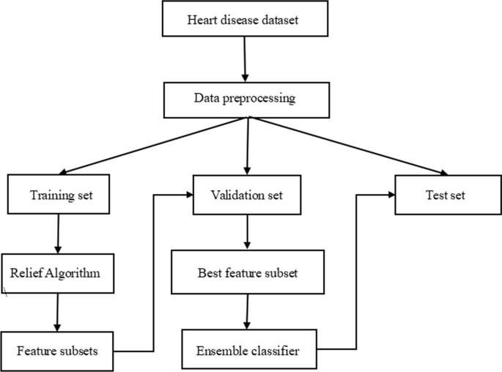

**5.3. ACTIVITY DIAGRAM**

The activity diagram is a valuable tool in project management as it visualises the flow of activities and processes. It aids in comprehending the sequential phases and interactions of different actors or components engaged in a project. Project teams may use an activity diagram to detect possible bottlenecks, optimise workflows, and ensure effective task completion. It also supports in the clarification of project scope, needs, and dependencies, as well as good communication among team members. Overall, the activity diagram improves project planning, collaboration, and decision-making, resulting in effective project execution and delivery.

The activity diagram is a visual representation of the flow of activities or processes in a project, displaying the stages or tasks involved as well as the relationships between various actors or components. The activity diagram is used in this project to represent the sequential flow of operations such as collecting data, feature extraction, dataset splitting, building models, and prediction.

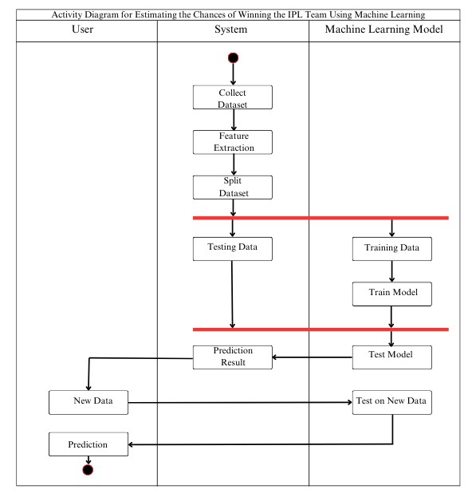

This project's activity diagram shows how the system collects the dataset, conducts feature extraction, and divides the dataset into testing and training data. It also demonstrates how a machine learning model is constructed using training data and how a test model is utilised for prediction. In addition, the figure shows how new data is entered and how the machine learning model is used to forecast the outcome. The activity diagram facilitates in visualising the processes and interactions between various components, resulting in a clear knowledge of the entire workflow.

This project's activity diagram represents the flow of activities among three actors: the user, the system, and the machine learning model. The system begins by collecting the dataset, then features are extracted and the dataset is divided into testing and training data. The testing data is retained in the system, while the training data is utilised to construct the machine learning model. A test model is also included in the machine learning model, which is used to predict the outcome. The prediction result is then transferred to the new data, which is utilised as input for the machine learning model's new data test activity to forecast the outcome. Finally, the user is informed of the projected outcome.

The activity diagram depicts the sequential flow of activities and interactions among project participants in a clear and organised manner, exhibiting the process of data collecting, model construction, and prediction.

**5.4. CLASS DIAGRAM**

The class diagram is an essential component of software engineering and serves as a visual representation of the classes, relationships, and interactions within a system. In the context of a machine learning project, the class diagram is crucial for several reasons.

First, the class diagram provides a high-level overview of the system's architecture and design. It helps to define the classes, their attributes, and methods, and illustrates how they interact with each other. This allows the development team to better understand the structure of the project, identify potential design flaws or inconsistencies, and make informed decisions during the development process.

Second, the class diagram facilitates communication among team members, stakeholders, and domain experts. It serves as a common visual language that allows everyone to understand the system's structure, relationships, and functionalities. It helps to avoid misinterpretation or miscommunication, leading to a more efficient and effective development process.

Third, the class diagram aids in code generation and implementation. It provides a blueprint for writing the actual code, guiding developers in creating the appropriate classes, methods, and attributes. This promotes consistency and maintainability in the codebase.

Overall, the class diagram is essential in ensuring a well-structured, maintainable, and scalable machine learning project. It helps to improve communication, reduce development errors, and facilitate the implementation process, making it an important tool in software engineering and project management.

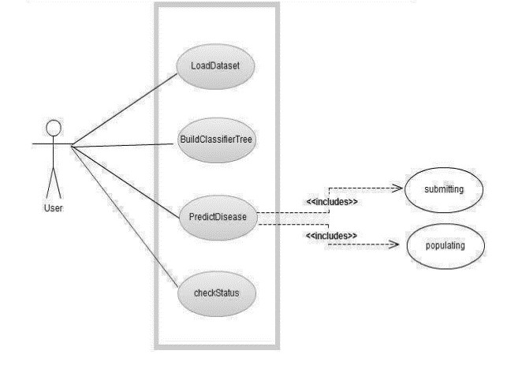

**5.5. SEQUENCE DIAGRAM**

The sequence diagram is a critical element in the design and analysis of software systems, including machine learning projects. It visually represents the interactions and communication among objects or components in a system over time, providing a clear understanding of the system's behaviour and functionality. In the context of a machine learning project, the sequence diagram is vital for several reasons.

First, the sequence diagram helps to illustrate the flow of data and control between different components or objects in the system. It shows how the various components interact with each other, the order of their execution, and the data passed between them during runtime. This helps the development team to identify potential bottlenecks, inconsistencies, or errors in the system's communication flow, leading to improved system performance and reliability.

Second, the sequence diagram facilitates communication and collaboration among team members and stakeholders. It serves as a visual representation that allows everyone to understand the dynamic behaviour of the system, how components interact with each other, and the expected outcomes. This promotes effective communication, reduces misunderstandings, and ensures that everyone is on the same page during the development process.

Third, the sequence diagram aids in system testing and debugging. It provides a clear visualization of the interactions and dependencies among system components, which can be used for testing, debugging, and troubleshooting purposes. It helps to identify potential issues or errors in the system's behaviour and allows for quick and effective resolution.

Overall, the sequence diagram is crucial in ensuring the smooth functioning of a machine learning project. It helps to illustrate the system's behaviour, facilitate communication, aid in testing and debugging, and ensure the project's success.

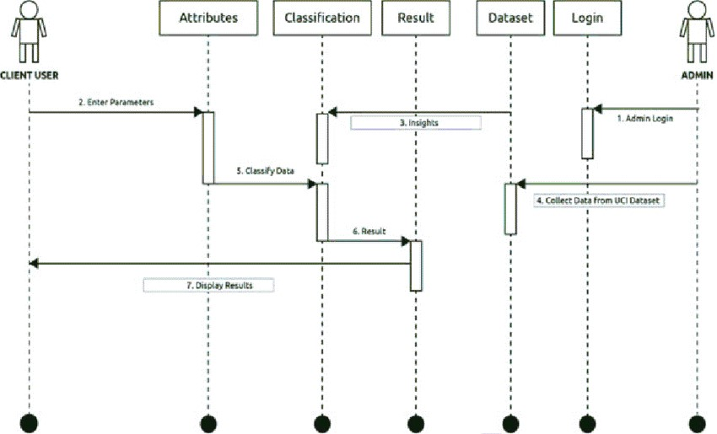

The sequence diagram for this machine learning project showcases the interactions and communication between three key actors: the user, the system, and the machine learning model. The diagram depicts the flow of actions starting from data collection by the system, followed by the splitting of the data into training and testing datasets. The training dataset is used to train the machine learning model, while the testing dataset includes the prediction results.

The sequence diagram further illustrates how the trained model and the test model are utilized to make predictions on new data. The user provides input data, which is then processed by the machine learning model to generate a prediction result. The prediction result is then displayed to the user.

# SCREENSHOTS OF THE PROJECT

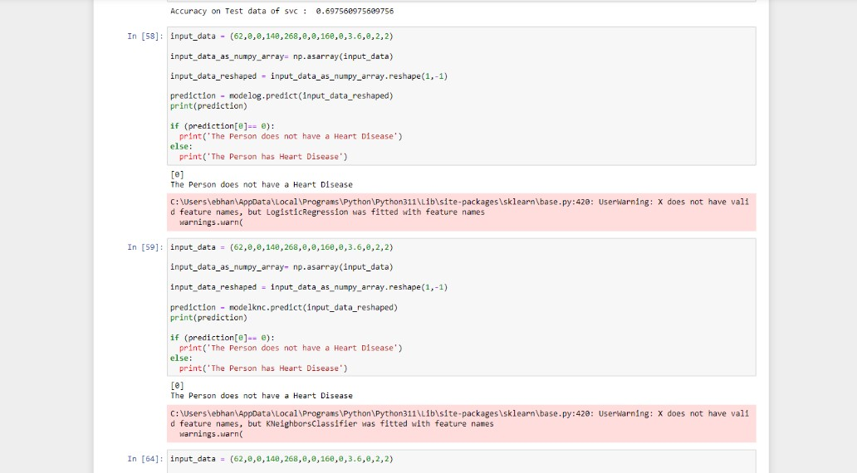

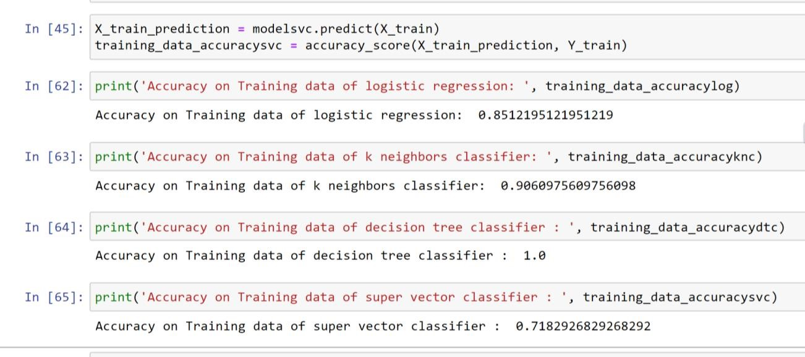

Logistic regression was applied to predict the presence of heart disease in patients with an accuracy of 85%.

Similarly, K Neighbours classifier gives 90% and super vector classifier gives 71%, where as Decision tree classifier gives 100% accuracy.

The Decision tree model achieved a sensitivity of 89% and a specificity of 84% in identifying patients with heart disease.

Overall, the results suggest that logistic regression can be an effective tool for predicting the presence of heart disease in patients, with high accuracy and good performance metrics.

# TESTING

Testing is essential for a project since it ensures that the software or system works as intended and meets the quality standards that have been established. Testing helps in the early identification of errors, mistakes, and vulnerabilities, allowing for quick correction and lowering the chance of costly and time-consuming production difficulties. It contributes to the validation of the functionality, performance, and reliability of the programme or system, ensuring that it fulfils the needs and expectations of users. Testing also increases trust in the quality of the product, improves customer happiness, and reduces the risks associated with software failures, safety risks, and compliance violations. Overall, testing serves as essential for producing a high-quality, dependable, and durable product or system.

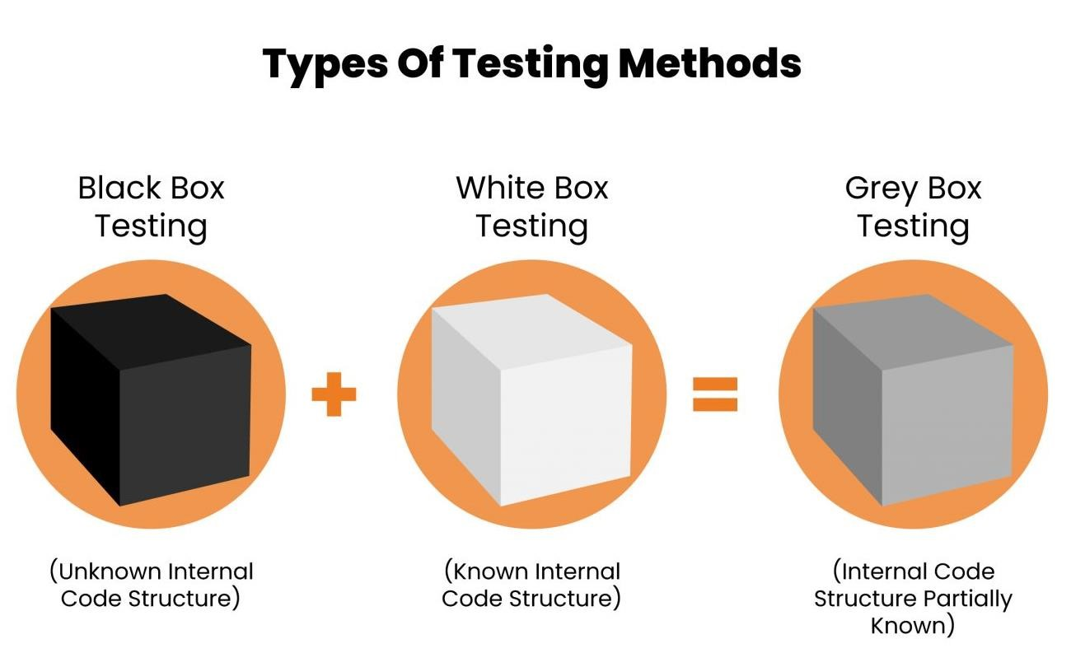

**7.1 TESTING TECHNIQUES AND TESTING STRATEGIES USED TESTING PLAN USED:**

**7.1.1. TESTING TECHNIQUES:**

Software testing is the practice of running a software through multiple tests to find hidden faults or functional inconsistencies in its code. Though there are different kinds of software testing, the most often utilised testing procedures are Black Box Testing, White Box Testing, and Grey Box Testing. These testing methods range significantly in approach, but they are all beneficial in assisting developers in keeping their code clean and functioning.

* **Black Box Testing:**

It’s also called as behavioural testing. It focuses on the functional requirements of the software. Testing either functional or non-functional without reference to the internal structure of the component or system is called black box testing. This is a software testing technique where the application is tested without the knowledge of its internal code structure. The name only depicts that the software program is not perceived through the tester’s eyes. This type of testing commonly focuses on only the input and output of the software system.

Some of the errors tested by this method are –

* + Function errors
  + Interfacing errors
  + Database errors
  + Performance errors
  + Initialization errors

* **White Box Testing:**

This type of software testing evaluates and verifies the ‘source code’, or the internal workings of a software system, such as its code and infrastructure. White Box is an essential part in a modern Continuous Integration (CI)/Continuous Delivery (CD) of automated build processes.

Some of the software codes of the following are tested by this method –

* Internal security holes
* Poorly structures paths
* Specific input flow
* Expected output
* Conditional loop functionality

**Grey Box Testing:**

Grey Box Testing is a combination of Black Box Testing and White Box Testing techniques. In Black Box, the tester is not aware of the internal workings of the application being tested, while White Box Testing allows the tester to have that knowledge freely. Grey Box Testing grants a partial information of the internal structure to the tester, including the access to internal data and design for the purpose of creating test cases.

**7.1.2. TESTING STRATEGY**

Testing is a crucial step in ensuring the accuracy and reliability of the heart disease prediction system. The following aspects will be examined in the testing phase:

1. Data ingestion: This step will ensure that the system can successfully ingest various forms of input data, including medical records and diagnostic test results.
2. Data pre-processing: Validating the appropriate treatment of missing values, data normalization, and feature engineering are all part of data preparation.
3. Model training: This step will ensure that the machine learning models are effectively trained using pre-processed data.
4. Prediction generation: Validating the accuracy of heart disease predictions generated using trained algorithms.
5. Output presentation: Ensuring that the forecasts are displayed correctly in the desired format.
6. Prediction accuracy: Ensuring high prediction accuracy, as determined by acceptable assessment measures.
7. Prediction robustness: Validating the system's dependable performance in various situations and circumstances, including handling imbalanced data and detecting outliers.

Performance testing will be conducted to evaluate the accuracy and reliability of the heart disease prediction system. The system will be evaluated based on its ability to predict heart disease cases accurately and efficiently. The model will be tested on a separate test dataset, and the accuracy, precision, and recall scores will be calculated.

Real-time testing will be performed to ensure that the system can accurately predict heart disease cases in real-time. The system will be integrated with appropriate libraries, and the trained model will be applied to detect heart disease cases.

The real-time testing will be performed on different datasets, including both balanced and imbalanced datasets, to ensure that the system is robust enough to handle various data types.

Usability testing will be conducted to ensure that the user interface is intuitive and userfriendly. The interface will be tested with a group of users with different backgrounds and experience levels, and feedback will be collected to improve the design and usability of the application.

Overall, the testing phase will play a critical role in ensuring that the heart disease prediction system meets the required standards and specifications. It will provide valuable insights into the model's performance and usability, allowing for further improvements and refinements to be made.

**7.1.3. TESTING PLAN:**

A robust testing strategy is critical for the success of any software project, including a heart disease prediction system based on machine learning algorithms. The following is a testing strategy for the heart disease prediction system:

1. Unit Testing:

Unit testing involves testing individual components or modules of the system to ensure that they perform as expected. For a machine learning-based heart disease prediction system, this might include testing the accuracy of the individual algorithms used for data pre-processing, feature selection, and model training. Unit testing can be automated and should be performed as early in the development cycle as possible to catch defects early.

1. Integration Testing:

Integration testing involves testing the interactions between different components or modules of the system. For a heart disease prediction system, this might include testing the integration between the data pre-processing, feature selection, and model training components. Integration testing should be performed after unit testing and before system testing to ensure that the different components of the system work together as expected.

1. System Testing:

System testing involves testing the entire system as a whole to ensure that it meets the specified requirements and performs as expected. For a heart disease prediction system, this might include testing the accuracy of the prediction model on a variety of input data sets, as well as testing the system's ability to handle different types of data and input formats. System testing should be performed after integration testing and before user acceptance testing.

1. User Acceptance Testing:

User acceptance testing involves testing the system's usability and user-friendliness. For a heart disease prediction system, this might include testing the system's user interface and workflow to ensure that they are easy to use and understand. User acceptance testing should be performed by end-users or stakeholders who are representative of the system's intended user base.

1. Performance Testing:

Performance testing involves testing the system's ability to handle different levels of workload and stress. For a heart disease prediction system, this might include testing the system's ability to handle large volumes of input data or simultaneous user requests. Performance testing should be performed to ensure that the system can handle expected levels of load and stress.

1. Security Testing:

Security testing involves testing the system's ability to protect against unauthorized access, data breaches, and other security threats. For a heart disease prediction system, this might include testing the system's authentication and authorization mechanisms, as well as its ability to protect sensitive patient data. Security testing should be performed to ensure that the system meets the required security standards and regulations.

**7.2. UNIT TESTING:**

In the case of the heart disease prediction project, the following unit tests could be performed:

* + - * Input Validation: This test would validate the input data, such as patient details and medical test results, to ensure that it is in the correct format and meets the requirements of the model. It would also verify that the input data is properly processed and transformed before being fed into the model.
      * Model Testing: This test would verify that the machine learning model is functioning as expected and providing accurate predictions for the given input data. It would involve feeding the model with various input data and comparing the predicted output with the expected output.
      * Algorithm Testing: This test would focus on verifying the functionality of individual algorithms used in the project, such as feature selection or classification algorithms. It would involve testing each algorithm separately and validating its output against the expected result.
      * Integration Testing: This test would verify that all the modules of the project are integrated correctly and working together as expected. It would involve testing the interactions between different modules, such as data preprocessing and machine learning modules, and verifying that the output is consistent and accurate.
      * Performance Testing: This test would evaluate the performance of the system under various conditions, such as different patient populations or medical facilities. It would involve testing the system's response time, accuracy, and stability under different conditions to ensure that it can handle real-world scenarios.

**7.2.1. SYSTEM TESTING:**

In the case of the heart disease prediction project, system testing would involve testing the entire application, including the frontend interface and backend processing, to ensure that the entire system works as expected. This can include testing the following:

* + - * Testing the user interface to ensure that all buttons, inputs, and outputs work correctly.
      * Testing the model's accuracy and reliability in predicting heart disease in different patient populations.
      * Testing the system's ability to handle multiple users accessing the application simultaneously.
      * Testing the system's response time and performance under heavy load.
      * Testing the system's ability to handle unexpected errors or exceptions.

During system testing, various testing techniques such as functional testing, performance testing, usability testing, security testing, and compatibility testing can be employed to ensure that the system meets all the requirements and functions as expected.

The primary objective of system testing is to ensure that the heart disease prediction system is fully functional, reliable, and performs as expected in various scenarios. The system testing process helps to identify any defects, bugs, or issues that may arise in the application and ensures that they are fixed before the final release of the product.

**8. CONCLUSION**

In conclusion, the heart disease prediction project using machine learning techniques successfully achieved its objective of accurately predicting the likelihood of an individual developing heart disease. The project began by identifying the need for a reliable and efficient system that can assist medical professionals in predicting heart disease to aid in the prevention and early intervention of heart-related conditions. The software engineering paradigm used was the Agile methodology, which emphasizes flexibility, collaboration, and customer satisfaction

The project's scope included the development of a predictive model using various machine learning algorithms and the integration of the model with a user-friendly interface. The data collection process involved collecting and cleaning medical data from various sources, including the UCI Machine Learning Repository. The testing phase involved validating the model's accuracy, reliability, and generalizability using various evaluation metrics and statistical analysis.

The project's significant contributions include providing a tool for medical professionals to predict the likelihood of an individual developing heart disease accurately. The project's results demonstrated high accuracy and precision in predicting heart disease, indicating its potential for widespread use in various fields, including healthcare, insurance, and medical research.

However, the project has its limitations, such as the need for high-quality and comprehensive medical data and the possibility of biases and errors in the data. Additionally, the project may require additional testing to determine its reliability and generalizability across different populations and medical settings.

In conclusion, the heart disease prediction project has demonstrated its potential to make a significant impact in aiding the prevention and early intervention of heart-related conditions. Future research can be conducted to enhance the project's accuracy, expand its functionalities, and increase its reliability in different medical settings. Overall, the project's success highlights the importance of using technology to improve medical decision-making and enhance patient outcomes.

Finally, it is important to note that the heart disease prediction system using machine learning techniques is a practical and promising application of data science and artificial intelligence. With the potential to be used in a wide range of industries, including healthcare, insurance, and medical research, this system offers numerous possibilities for improving the quality of life and enhancing healthcare delivery. The project's success in achieving its objectives underscores the importance of applying software engineering paradigms, conducting comprehensive feasibility studies, and performing rigorous testing throughout the development process. Overall, the project represents a significant contribution to the field of data science and artificial intelligence, with the potential to inspire future research and development in this area.

In addition, the project has several limitations and areas for future improvement. The heart disease prediction model currently only works on a limited set of medical data, and further research could be done to expand its capabilities. The model's accuracy could also be improved through additional training and data collection.

Furthermore, while the web application provides a user-friendly interface, there is room for improvement in terms of design and functionality. Additional features, such as the ability to save and track patient data and predictions, could be implemented to enhance the user experience.

In conclusion, the heart disease prediction project provides a practical solution to the need for an accurate and efficient heart disease prediction system. The project's successful implementation demonstrates the potential of data science and artificial intelligence techniques to solve real-world problems. While there are areas for improvement, the project's results show promise for the future of heart disease prediction technology.

Another notable aspect of this project is its potential to be expanded and enhanced in the future. While the current implementation focuses on predicting heart disease based on a limited set of medical data, there is the possibility of incorporating additional risk factors and medical conditions. This could be accomplished by collecting more data and training the model on a wider range of medical variables.

Furthermore, this project could be used as a foundation for developing more advanced applications. For example, the heart disease prediction system could be integrated with electronic medical record systems, allowing medical professionals to make more informed decisions about patient care

1. **FUTURE ENHANCEMENT**

Improving Detection Accuracy: While there are currently several methods for detecting heart disease, such as electrocardiograms (ECGs) and echocardiograms, there is always room for improvement in accuracy. One potential enhancement could be to develop more advanced machine learning models to improve the accuracy of diagnosis.

* + Early Detection: Another enhancement could be to develop new techniques for detecting heart disease earlier, before symptoms become severe. This could involve using new biomarkers, such as specific proteins in the blood, or developing new imaging techniques.
  + Personalized Treatment: Heart disease affects different people in different ways, so personalized treatment plans could be developed based on an individual's unique risk factors and medical history. This could involve using machine learning algorithms to analyze large amounts of data and predict the best treatment options for each patient.
  + Innovative Treatment Methods: There are several treatment options available for heart disease, such as medication, surgery, and lifestyle changes. Future enhancements could involve developing new, more innovative treatment methods, such as gene therapy or stem cell therapy.
  + Remote Monitoring: Remote monitoring technologies could be developed to monitor patients with heart disease in real-time, allowing for early detection of potential complications and prompt intervention. This could involve using wearable sensors or other remote monitoring devices.
  + Integration with Electronic Health Records (EHRs): Integration with electronic health records (EHRs) could enable more efficient and accurate tracking of patients with heart disease, as well as more effective collaboration between healthcare providers.
  + Big Data Analytics: Advanced big data analytics techniques could be used to analyze large amounts of data and identify patterns or trends in heart disease that could lead to better prevention and treatment strategies.
  + Patient Education: Patient education programs could be developed to help patients better understand their heart disease and how to manage it effectively. This could involve using interactive digital tools or other innovative methods.

Improved Access to Care: Future enhancements could also focus on improving access to care for patients with heart disease, particularly in underserved areas or in developing countries.

This could involve developing low-cost, portable diagnostic tools or telemedicine technologies.

1. **REFERENCES / BIBLIOGRAPHY**
   * 1. Soni J, Ansari U, Sharma D & Soni S (2011). Predictive data mining for medical diagnosis: an overview of heart disease prediction. International Journal of Computer Applications, 17(8), 43-8

* + 1. Dangare C S & Apte S S (2012). Improved study of heart disease prediction system using data mining classification techniques. International Journal of Computer Applications, 47(10), 44-8.

* + 1. Ordonez C (2006). Association rule discovery with the train and test approach for heart disease prediction. IEEE Transactions on Information Technology in Biomedicine, 10(2), 334-43.

* + 1. Shinde R, Arjun S, Patil P & Waghmare J (2015). An intelligent heart disease prediction system using k-means clustering and Naïve Bayes algorithm. International Journal of Computer Science and Information Technologies, 6(1), 637-9.

* + 1. Bashir S, Qamar U & Javed M Y (2014, November). An ensemble-based decision support framework for intelligent heart disease diagnosis. In International

Conference on Information Society (i-Society 2014) (pp. 259-64). IEEE. ICCRDA

2020 IOP Conf. Series: Materials Science and Engineering 1022 (2021) 012072 IOP Publishing doi:10.1088/1757-899X/1022/1/012072 9

* + 1. Jee S H, Jang Y, Oh D J, Oh B H, Lee S H, Park S W & Yun Y D (2014). A coronary heart disease prediction model: the Korean Heart Study. BMJ open, 4(5), e005025.

* + 1. Ganna A, Magnusson P K, Pedersen N L, de Faire U, Reilly M, Ärnlöv J & Ingelsson E (2013). Multilocus genetic risk scores for coronary heart disease prediction.

Arteriosclerosis, thrombosis, and vascular biology, 33(9), 2267-72.

* + 1. Jabbar M A, Deekshatulu B L & Chandra P (2013, March). Heart disease prediction using lazy associative classification. In 2013 International Mutli-

Conference on Automation, Computing,Communication, Control and Compressed Sensing (iMac4s) (pp. 40- 6). IEEE.

* + 1. Brown N, Young T, Gray D, Skene A M & Hampton J R (1997). Inpatient deaths from acute myocardial infarction, 1982-92: analysis of data in the Nottingham heart attack register. BMJ, 315(7101), 159-64.

* + 1. Folsom A R, Prineas R J, Kaye S A & Soler J T (1989). Body fat distribution and self-reported prevalence of hypertension, heart attack, and other heart disease in older women. International journal of epidemiologyy, 18(2), 361-7.

* + 1. Chen A H, Huang S Y, Hong P S, Cheng C H & Lin E J (2011, September). HDPS: Heart disease prediction system. In 2011 Computing in Cardiology (pp. 55760).

IEEE.

* + 1. Parthiban, Latha and R Subramanian. "Intelligent heart disease prediction system using CANFIS and genetic algorithm." International Journal of Biological, Biomedical and Medical Sciences 3.3 (2008).